2024 Air Quality Annual Status Report (ASR)
In fulfilment of Part IV of the Environment Act 1995 Local Air Quality Management, as amended by the Environment Act 2021
Date: June 2024

Information | Details
Local Authority Officer | Ben Frost-Jones
Department | Environmental Protection
Address | Dorset Council  County Hall  Dorchester  Dorset  DT1 1XJ
Telephone | 01305 221000
E-mail | envhealth@dorsetcouncil.gov.uk
Report Reference Number | DC_ASR_2024
Date | June 2024

Executive Summary: Air Quality in Our Area

Air Quality in Dorset
Breathing in polluted air affects our health and costs the NHS and our society billions of pounds each year. Air pollution is recognised as a contributing factor in the onset of heart disease and cancer and can cause a range of health impacts, including effects on lung function, exacerbation of asthma, increases in hospital admissions and mortality. In the UK, it is estimated that the reduction in healthy life expectancy caused by air pollution is equivalent to 29,000 to 43,000 deaths a year.
Air pollution particularly affects the most vulnerable in society, children, the elderly, and those with existing heart and lung conditions. Additionally, people living in less affluent areas are most exposed to dangerous levels of air pollution.
Table ES 1 provides a brief explanation of the key pollutants relevant to Local Air Quality Management and the kind of activities they might arise from.
Table ES 1 - Description of Key Pollutants
Pollutant | Description
Nitrogen Dioxide (NO₂) | Nitrogen dioxide is a gas which is generally emitted from high-temperature combustion processes such as road transport or energy generation.
Sulphur Dioxide (SO₂) | Sulphur dioxide (SO₂) is a corrosive gas which is predominantly produced from the combustion of coal or crude oil.
Particulate Matter  (PM₁₀ and PM_{2.5}) | Particulate matter is everything in the air that is not a gas.  Particles can come from natural sources such as pollen, as well as human made sources such as smoke from fires, emissions from industry and dust from tyres and brakes.  PM₁₀ refers to particles under 10 micrometres. Fine particulate matter or PM_{2.5} are particles under 2.5 micrometres.

Air quality throughout Dorset Council has been assessed and has been found to be broadly very good, due to the predominantly rural environment. However, in certain locations air quality has been found to be close to, or exceeding the objective level for nitrogen dioxide (NO₂), the main source of pollution being from road traffic. This is due to vehicle emissions and other factors including type and number of vehicles, their speed, congestion and local topographical circumstances. As a result of this, an Air Quality Management Area was declared in Chideock in 2007, and High East Street, Dorchester in 2009. (https://www.dorsetcouncil.gov.uk/environmental-health/documents/air-quality-management-order-2007-chideock.pdf https://www.dorsetcouncil.gov.uk/environmental-health/documents/air-quality-management-order-2009-dorchester.pdf )
In February 2018, Government approved plans to create two new unitary councils in Dorset. On 1st April 2019, the former borough, county and district councils ceased to exist and were replaced by two unitary authorities: BCP Council and Dorset Council. Any reference to previous districts refers to geographical divisions used to facilitate effective and efficient management of air quality monitoring.

Actions to Improve Air Quality
Whilst air quality has improved significantly in recent decades, there are some areas where local action is needed to protect people and the environment from the effects of air pollution.
The Environmental Improvement Plan sets out actions that will drive continued improvements to air quality and to meet the new national interim and long-term targets for fine particulate matter (PM_{2.5}), the pollutant of most harmful to human health. The Air Quality Strategy provides more information on local authorities' responsibilities to work towards these new targets and reduce fine particulate matter in their areas.
The Road to Zero details the Government’s approach to reduce exhaust emissions from road transport through a number of mechanisms, in balance with the needs of the local community. This is extremely important given that cars are the most popular mode of personal travel and the majority of Air Quality Management Areas (AQMAs) are designated due to elevated concentrations heavily influenced by transport emissions.
Primary actions taken to improve air quality in Dorset principally revolve around the new Air Quality Action Plan for Chideock and the harmonisation and streamlining of air quality monitoring practices between teams following formation of the new council. National Highways (formerly Highways England), who hold responsibility for actions regarding the A35 trunk road passing through Dorset – the principal source of NO₂ emissions in the AQMA in Chideock – have seen success also with the extension of the 30mph speed limit, the permanent implementation of which is currently underway. Dorset Council continue to work with our colleagues at National Highways, as well as our own Highways Department, Public Health Dorset and elected members and Parish Councils.
Further working is being undertaken as part of a DEFRA-funded project to monitor and quantify emissions from solid-fuel burning appliances. This seeks to quantify PM emissions in locales with higher numbers of solid-fuel burners, and measure the impact of behaviour change initiatives and campaigns. This project is due for completion in summer/autumn 2024. Partners in Public Health and Litter Free Dorset are partnering with Environmental Protection to further extend anti-idling schemes outside schools, and to extend the school-streets programme which closes roads around schools at drop-off and pick-up times.

Conclusions and Priorities
2023 monitoring has demonstrated annual average exceedances at monitoring sites in Dorset once bias adjustment has occurred. These are all within the Chideock AQMA. The overall picture remains fairly mixed: although there are a few sites that have increased, most sites have decreased concentrations on 2022. Sites generally remain below 2019 levels contributing to an overall downward trend. Caution is advised against making significant strategic decision on the basis of 2023 results, however the continuation of the downward trend in air pollution is welcome.

Chideock monitoring sites remain below 2019 concentrations and show a general decrease on 2022 concentrations too. Exceedances of the 40µg/m³ Air Quality Objective (AQO) have occurred at two sites: W39 – 54.4µg/m³; and H6 – 57.9µg/m³. These sites are on the Chideock Hill incline. Both sites provided exceedances in 2022, and when distance corrected, W39 is compliant with the objective (39.7 µg/m³). All W-numbered Chideock sites, and all but one H site demonstrate a downwards trend in comparison with 2022 concentrations.

Sites within Dorchester AQMA broadly demonstrate consistent levels with 2022. Both monitoring sites rest at least 10% below the AQO. Dorset Council intends to revoke the AQMA in 2024, as the air quality has remained at least 10% below the minimum objective. The above caution regarding strategic decisions is heeded in this case.
Sites within the Bridport East Road area have decreased since 2022 with no sites within 10% of the AQO. Monitoring will continue into 2024.

Sites in Weymouth, including the Boot Hill area largely show improved air quality on 2022, with some sites showing increases in concentrations. One site has increased to within 10% of the AQO – W12 (36.1 µg/m³), with W5 and W13 also showing increases on 2022. Of these, only W12 has concentrations greater than 2019. Monitoring will continue during 2024 with further provision planned for the Boot Hill area.

Air Quality in both former East Dorset and Purbeck districts remains very good, with no identified AQMAs, areas for concern, exceedances or sites within 10% of the AQO. All but one site shows a slight decrease on 2022 concentrations, however these sites remain at less than, or in proximity to, half of the annual mean. Monitoring continues to take place, with careful consideration given to sites near significant developments and those guided by public and member requests.

No exceedances of the PM₁₀ annual mean objective were detected across four sites in Dorset, with all four sites having 24-hour means over 50µg/m³ but within the permitted 35 times per year threshold. The Blandford monitor has remained out of operation due to power malfunctions for the majority of the year, meaning its data should not be regarded as accurate (7% annual data collection). Beaminster’s annual mean continued to demonstrate a downwards trend, and concentrations in Ferndown returned to levels broadly consistent with a downwards trend since 2019. Sandford remains at levels broadly consistent with the 2022 concentration, indicating that systemic changes may have occurred to increase PM pollution in the area. Further monitoring of the sites will continue.

Annual mean PM_{2.5} levels show a mixed picture across Dorset, with a general downward trend. Beaminster concentrations continue to fall on pandemic levels, although is increased on an anomalously low 2022 result. Blandford’s result is not considered accurate due to low data capture (7% annual data collection). Ferndown and Sandford have remained consistent with 2022 concentrations. Overall, the PM_{2.5} outlook in Dorset remains good, with all sites remaining below the future 2040 target of 10µg/m³. This is advised with caution however. An increase in PM monitoring across Dorset is now underway, although has been delayed beyond the deadline for the 2024 ASR.

We continue to work with other council services including Highways and Planning, the Environment Agency and local businesses by way of the permitting regime to ensure that air quality is continually reviewed. In addition, Public Health Dorset’s pan-Dorset PM_{2.5} project continues but will be reviewed in late 2024.

Local Engagement and How to get Involved

Our Local Plan states “Everyone has a role to play in tackling climate change and in adapting to its impacts. Community based initiatives such as local car share schemes, village hall investments, biofuel utilisation, community emergency support and renewable energy part ownership will be supported by the Council. Neighbourhood plans may address the adaptation and mitigation of climate change at the community level as recognition that all neighbourhoods can contribute towards tackling climate change in a way which is appropriate to their local area.”
The Dorset Council website https://www.dorsetcouncil.gov.uk/travel/travel.aspx includes measures the public can actively use to improve air quality within the area, these include matters such as interactive cycle maps, adult cycle training and walking routes and trails.

Local Responsibilities and Commitment
This ASR was prepared by the Environmental Protection Department of Dorset Council with the support and agreement of the following officers and departments:
Environmental Protection
Development Control
Building Control
Public Health Dorset
Highways

This ASR has been signed off by:
Graham Duggan – Head of Community and Public Protection
Sam Crowe – Director of Public Health

If you have any comments on this ASR please send them to Ben Frost-Jones at:
County Hall, Colliton Park, Dorchester, Dorset, DT1 1XJ
01305 221000
envhealth@dorsetcouncil.gov.uk

Table of Contents
Executive Summary: Air Quality in Our Area i
Air Quality in Dorset i
Actions to Improve Air Quality iii
Conclusions and Priorities iv
Local Engagement and How to get Involved iv
Local Responsibilities and Commitment v
1 Local Air Quality Management 1
2 Actions to Improve Air Quality 2
2.1 Air Quality Management Areas 3
2.2 Progress and Impact of Measures to address Air Quality in Dorset 8
2.3 PM_{2.5} – Local Authority Approach to Reducing Emissions and/or Concentrations 14
3 Air Quality Monitoring Data and Comparison with Air Quality Objectives and National Compliance 16
3.1 Summary of Monitoring Undertaken 17
3.1.1 Automatic Monitoring Sites 17
3.1.2 Non-Automatic Monitoring Sites 17
3.2 Individual Pollutants 18
3.2.1 Nitrogen Dioxide (NO₂) 18
3.2.2 Particulate Matter (PM₁₀) 21
3.2.3 Particulate Matter (PM_{2.5}) 22
Appendix A: Monitoring Results 25
Appendix B: Full Monthly Diffusion Tube Results for 2023 49
Appendix C: Supporting Technical Information / Air Quality Monitoring Data QA/QC 51
New or Changed Sources Identified Within Dorset During 2023 52
Additional Air Quality Works Undertaken by Dorset During 2023 52
QA/QC of Diffusion Tube Monitoring 53
Diffusion Tube Annualisation 53
Diffusion Tube Bias Adjustment Factors 55
NO₂ Fall-off with Distance from the Road 57
QA/QC of Automatic Monitoring 59
PM₁₀ and PM_{2.5} Monitoring Adjustment 59
Automatic Monitoring Annualisation 60
NO₂ Fall-off with Distance from the Road 60
Appendix D: Map(s) of Monitoring Locations and AQMAs 62
Appendix E: Summary of Air Quality Objectives in England 64
Glossary of Terms 65
References 66

Figures
Figure A.1 – Trends in Annual Mean NO₂ Concentrations 32
Figure A.3 – Trends in Annual Mean PM₁₀ Concentrations 40
Figure A.4 – Trends in Number of 24-Hour Mean PM₁₀ Results > 50µg/m³ 43
Figure A.5 – Trends in Annual Mean PM_{2.5} Concentrations 46

Figure D.1 – Map of Non-Automatic Monitoring Site 62
Tables
Table 2.1 – Declared Air Quality Management Areas 5
Table 2.2 – Progress on Measures to Improve Air Quality 10

Table A.1 – Details of Automatic Monitoring Sites 25
Table A.2 – Details of Non-Automatic Monitoring Sites 26
Table A.3 – Annual Mean NO₂ Monitoring Results: Automatic Monitoring (µg/m³) 27
Table A.4 – Annual Mean NO₂ Monitoring Results: Non-Automatic Monitoring (µg/m³) 29
Table A.5 – 1-Hour Mean NO₂ Monitoring Results, Number of 1-Hour Means > 200µg/m³ 35
Table A.6 – Annual Mean PM₁₀ Monitoring Results (µg/m³) 38
Table A.7 – 24-Hour Mean PM₁₀ Monitoring Results, Number of PM₁₀ 24-Hour Means > 50µg/m³ 41
Table A.8 – Annual Mean PM_{2.5} Monitoring Results (µg/m³) 44

Table B.1 – NO₂ 2023 Diffusion Tube Results (µg/m³) 49

Table C.1 – Annualisation Summary (concentrations presented in µg/m³) 54
Table C.2 – Bias Adjustment Factor 55
Table C.4 – Non-Automatic NO₂ Fall off With Distance Calculations (concentrations presented in µg/m³) 58

Table E.1 – Air Quality Objectives in England 64

Local Air Quality Management
This report provides an overview of air quality in Dorset during 2023. It fulfils the requirements of Local Air Quality Management (LAQM) as set out in Part IV of the Environment Act (1995), as amended by the Environment Act (2021), and the relevant Policy and Technical Guidance documents.
The LAQM process places an obligation on all local authorities to regularly review and assess air quality in their areas, and to determine whether or not the air quality objectives are likely to be achieved. Where an exceedance is considered likely the local authority must declare an Air Quality Management Area (AQMA) and prepare an Air Quality Action Plan (AQAP) setting out the measures it intends to put in place in order to achieve and maintain the objectives and the dates by which each measure will be carried out. This Annual Status Report (ASR) is an annual requirement showing the strategies employed by Dorset Council to improve air quality and any progress that has been made.
The statutory air quality objectives applicable to LAQM in England are presented in Table E.1.

Actions to Improve Air Quality
  - Air Quality Management Areas
Air Quality Management Areas (AQMAs) are declared when there is an exceedance or likely exceedance of an air quality objective. After declaration, the authority should prepare an Air Quality Action Plan (AQAP) within 18 months. The AQAP should specify how air quality targets will be achieved and maintained and provide dates by which measures will be carried out.
A summary of AQMAs declared by Dorset Council can be found in Table 2.1. The table presents a description of the two AQMAs that are currently designated within Dorset. Appendix D: Map(s) of Monitoring Locations and AQMAs provides maps of AQMAs and also the air quality monitoring locations in relation to the AQMAs. The air quality objectives pertinent to the current AQMA designations are as follows:
- NO₂ annual mean - 40µg/m³
We propose to revoke Dorchester AQMA in 2024 (see monitoring and additional section).

Table 2.1 – Declared Air Quality Management Areas

AQMA Name | Date of Declaration | Pollutants and Air Quality Objectives | One Line Description | Is air quality in the AQMA influenced by roads controlled by Highways England? | Level of Exceedance: Declaration | Level of Exceedance: Current Year | Number of Years Compliant with Air Quality Objective | Name and Date of AQAP Publication | Web Link to AQAP
AQMA Chideock | May 2007, Amended March 2012 | NO₂ Annual Mean | A35 in Chideock. | YES | 45.5 | 57.9 | 0 | Chideock Air Quality Action Plan, 2022 | https://moderngov.dorsetcouncil.gov.uk/documents/s30911/Appendix%20A%20Dorset%20Chideock%20AQAP%202022.pdf
AQMA Dorchester | May 2009 | NO₂ Annual Mean | High East Street, Dorchester | NO | 43 | 28.2 | 5* | Dorchester Air Quality Action Plan, 2011 | https://www.dorsetcouncil.gov.uk/documents/35024/281348/Air+Quality+Action+Plan+2011+-+Dorchester.pdf/f500d2db-d2d6-d92b-3306-414d0ce517cf

☒ Dorset Council confirm the information on UK-Air regarding their AQMA(s) is up to date.
☒ Dorset Council confirm that all current AQAPs have been submitted to Defra.

  - Progress and Impact of Measures to address Air Quality in Dorset
Defra’s appraisal of last year’s ASR concluded:
The report is well structured, detailed, and provides the information specified in the Guidance. The following comments are designed to help inform future reports:
- The Council plan a district-wide review of air quality monitoring in autumn 2023, to redistribute diffusion tube and AQMesh resources. Its great to see that the council is keeping is monitoring network under review.
- The report included detailed discussion of trends in monitoring data, set out by area. The statistics on traffic reduction were a good addition to aid in understanding trends. It would be great to see the tables in this section in the same format as the rest of the report.
- As with the previous years ASR, the local engagement section of the report is brief. It could be improved by including information on how the public can get involved in improving air quality. This would be beneficial for local residents of Dorset Council to use.
- Much of Table 2.2 hasn’t been filled in. This table should be completed in future reports. In particular estimated completion date, progress to date and barriers to implementation are important to understand the status and progress of measures.
- There are several instances of pollutant names and units are not appropriately superscripted or subscripted. Whilst this doesn’t affect the readability of the report. The council should endeavour to do this correctly in future reports.
- As with the previous years ASR, the priorities and proposed future actions for the coming year are not clearly identified and justified.
Dorset Council has taken forward a number of direct measures during the current reporting year of 2023 in pursuit of improving local air quality. Details of all measures completed, in progress or planned are set out in Table 2.2. 27 measures are included within Table 2.2, with the type of measure and the progress Dorset Council have made during the reporting year of 2023 presented. Where there have been, or continue to be, barriers restricting the implementation of the measure, these are also presented within Table 2.2.
More detail on these measures can be found in their respective Action Plans. Key completed measures are:
- Implementation of a permanent 30mph speed limit on Chideock Hill in partnership with National Highways which is now enforceable
- Increasing our provision of PM monitoring to include urban locations by way of DEFRA-funded project. These monitors will be rolled out for wider monitoring use once the project is concluded
- Information and marketing campaign to improve solid-fuel burning behaviours
- Renewal of Dorset Council pool-car fleet to include new plug-in electric vehicles
- Installation of 10 charging points for use by council staff

Dorset Council worked to implement these measures in partnership with the following stakeholders during 2023:
- Neighbouring local authorities;
- National Highways
- Public Health Dorset
- Local and national transport authorities
- Dorset and Wiltshire Fire and Rescue
- Dorset Police
- South West Ambulance Trust
- NHS

Whilst the measures stated above, below and in Table 2.2 will help to contribute towards compliance, Dorset Council anticipates that further additional measures not yet prescribed may be required in subsequent years to achieve compliance and enable the revocation of Chideock AQMA.

Low Carbon Dorset Programme
The programme is run by the council and the Dorset Area of Outstanding Natural Beauty (AONB). It aims to help improve energy efficiency, increase the use of renewable energy, and aid the development of new low carbon products. Dorset based businesses, public sector and community organisations can access free support and a fund pot of over £2.15m to help improve energy efficiency and develop renewable energy projects. https://www.lowcarbondorset.org.uk/

Climate Strategy and Ecological Action Plan
Dorset Council declared a Climate and Ecological Emergency in 2019 and established an Executive Advisory Panel to strategically guide the Councils response. A draft Climate and Ecological Emergency Strategy was produced in July 2020 which presented 8 key areas for action to ensure that Dorset Council becomes Carbon Neutral by 2040 and the Dorset Council Area by 2050 https://www.dorsetcouncil.gov.uk/climate- -emergency

Measures within the Action Plan will positively affect air quality throughout the Dorset Council area, and include:
- Ensure access to sustainable transport is considered in planning applications
- Investigate potential for small scale park & ride hubs with electric vehicle charging point availability
- Encourage decarbonisation of road transport through development of public EV charging network & promotion of ultra low emissions vehicles
- Expand cycle training and independent travel training programmes, and
- Explore introduction of a bike share scheme in larger settlements

Dorset Council Local Plan
Currently, Dorset Council is working on the new Local Plan to shape society, economy and the environment over a 15 year period. Consultation on it commenced early 2021, in readiness for its adoption in 2027.
The plan will:
- Protect and enhance Dorset’s natural environment and biodiversity
- Deliver suitable housing to Dorset’s needs
- Work to provide residents with a good quality of life with high quality and well designed developments
- Provide cycle ways and access to the countryside
Information can be found via https://www.dorsetcouncil.gov.uk/w/the-local-development-scheme-for-dorset-council-march-2024#introduction

Planning Applications
The Environmental Protection Team review all referred and validated planning applications for their air quality impact. Relevant guidance is followed when reviewing these applications, i.e. Land-Use Planning and Development Control: Planning for Air Quality, January 2017 (EPUK and IAQM). Where there is a potential adverse impact, or the development introduces new sensitive receptors within an AQMA, an air quality impact assessment is required. Where this identifies a significant adverse impact on air quality or human health then mitigation measures are required.

Local Transport Plan 3 2011 – 2026
The Local Transport Plan 3 (LTP3) is a statutory document which sets out a strategy for the management, maintenance and development of the County’s transport system. It sets out a way forward to deliver transport needs through short, medium and long term transport solutions and how transport can improve safety and health, support the local economy, protect the environment and reduce carbon emissions and pollution. The LTP3 came into effect in April 2011 and has been produced for the whole of Bournemouth, Poole and Dorset. It covers the period from 2011 to 2026 and is based on a longer term strategy (2011 – 2026) and shorter term implementation plan(s) (3 years). Further information can be found at https://www.dorsetcouncil.gov.uk/roads-highways-maintenance/transport-planning/local-transport-plan/local-transport-plan-3.aspx

A new travel plan covering from 2026 onwards is in the creation phase, and environmental health are consultees to feed into the process moving forwards. Initial discussions demonstrate a keenness from both officers and elected members to ensure air quality and its improvement is at the forefront of discussions.

Travel choice
This is a County-wide initiative to raise awareness about the impacts of travel behaviour and to encourage people to make informed decisions about journeys they make. For example information is provided on interactive cycle maps, adult cycle training and walking routes and trails. This initiative also promotes Car Share Dorset, an online tool to encourage and facilitate car sharing by matching journeys, run jointly by Dorset Council and Bournemouth, Chrischurch and Poole (BCP) Council. More information can be found https://www.dorsetcouncil.gov.uk/travel/travel.aspx and https://liftshare.com/uk/community/dorset

Industrial Installations
Certain industrial processes and activities which have the potential to cause pollution are required to have an Environmental Permit to operate. The Environmental Permitting (England and Wales) Regulations 2016 were made under the Pollution Prevention and Control Act 1999 and prescribe those processes and activities which require a permit. These processes are split into three categories: Part A (1), Part A(2) and Part B and are regulated by the Environment Agency and local authorities.

A list of Permitted Processes in the Dorset Council area is available from https://www.dorsetcouncil.gov.uk/business-consumers-licences/licences-and-permits/environmental-permits/public-register-of-environmental-permits-in-west-dorset
Table 2.2 – Progress on Measures to Improve Air Quality
Measure No. | Measure Title | Category | Classification | Year Measure Introduced in AQAP | Estimated / Actual Completion Date | Organisations Involved | Funding Source | Defra AQ Grant Funding | Funding Status | Estimated Cost of Measure | Measure Status | Reduction in Pollutant / Emission from Measure | Key Performance Indicator | Progress to Date | Comments / Barriers to Implementation
1 | Dorset Highways asset management plan (HAMP) | Transport Planning and Infrastructure | Public transport improvements-interchanges stations and services | 2018 | 2022 | DC | Capital | NO | Funded |  | Completed |  |  | HAMP
2 | Low Carbon Travel Strategy | Promoting Low Emission Transport | Other | 2011 | 2026 | DC/BCP | Capital | NO | Funded |  | Ongoing |  |  |  | 2026
3 | Promote and, as appropriate, implement road network improvements as identified through the Local Transport Plan and other related processes e.g. links to/from South West/Bristol/M4 e.g. A350/C13, road & rail links to/from Port of Poole and Weymouth/Portland Port, links to/from Bournemouth Airport. | Freight and Delivery Management | Route Management Plans/ Strategic routing strategy for HGV's | 2017 | 2019 | DC/BCP, DLEP, FQP, FTA, RHA, NH | Capital | NO | Funded |  | Completed |  |  |  | Superseded by new HAMP
4 | Sustainable Energy accross the Common Space (SEACS) | Promoting Low Emission Plant | Other measure for low emission fuels for stationary and mobile sources | 2011 | 2021 | Devon County Council Wiltshire Council 2 Local Uthority Partners from Brittany | INTERREG IV | NO | Funded |  | Completed |  |  | Completed | Brexit
5 | Dorset Solar Farm Community Benefits | Other | Other | 2014 | 2016 | Community Energy Team | Capital | NO | Funded |  | Completed
6 | Expand EV Charging Points & other ultra-low emission fuel alternatives | Promoting Low Emission Transport | Procuring alternative Refuelling infrastructure to promote Low Emission Vehicles, EV recharging, Gas fuel recharging | ongoing |  | DC | Capital | NO | Funded |  | Ongoing, but significant progress |  |  | 10 points installed at County Hall, Dorchester
7 | Improve cycle infrastructure | Promoting Travel Alternatives | Promotion of cycling | 2020 |  | DC / BCP | Transforming Cities Fund | NO | Funded |  | Implementation |  |  | Multiple new cycle routes and lanes in key commuting corridors
8 | Highways Maintenance | Traffic Management | Strategic highway improvements, Re-prioritising road space away from cars, including Access management, Selective vehicle priority, bus priority, high vehicle occupancy lane | 2019 |  |  | Capital | NO | Funded |  | Implementation
9 | Lobby Govt for rail improvements | Promoting Travel Alternatives | Intensive active travel campaign & infrastructure | 2019 |  | DC | Capital | NO | Funded |  | Implementation
10 | Respond to government calls and submit high quality grant applications | Promoting Travel Alternatives | Intensive active travel campaign & infrastructure | 2019 |  | DC | Capital | NO | Funded |  | Implementation
11 | Redirect investment from strategic road schemes to low carbon transport | Promoting Low Emission Transport | Other | 2019 |  | DC with STB & LEP | Capital | NO | Funded |  | Implementation
12 | Reinforce low carbon transport policies through statutory planning documents including refreshed LTP and new Draft Local Plan | Promoting Low Emission Transport | Other | 2019 |  | DC | Capital | NO | Funded |  | Implementation
13 | Ensure access to sustainable transport is considered in planning applications | Alternatives to private vehicle use | Other | 2019 |  | DC | Capital | NO | Funded |  | Implementation
14 | Investigate potential for small scale park & ride hubs with electric vehicle charging point availability | Alternatives to private vehicle use | Bus based Park & Ride | 2019 |  | DC | Capital | NO | Funded |  | Planning
15 | Encourage decarbonisation of road transport through development of public EV charging network & promotion of ultra low emissions vehicles, and including on-going management | Freight and Delivery Management | Delivery and Service plans | 2019 | 2024 | DC | Capital | NO | Funded |  | Implementation
16 | Encourage use of ultra low emission public transport vehicles (including taxis) – particularly smaller buses | Promoting Travel Alternatives | Intensive active travel campaign & infrastructure | 2019 | 2024 | DC | Capital | NO | Funded |  | Implementation
17 | Working closely with Dorset Business Travel Network and Digital Dorset to promote the use of ICT to individuals and businesses to avoid travel / encourage working from home | Promoting Travel Alternatives | Encourage / Facilitate home-working | 2019 | 2021 | DC / Dorset Business Travel Network / Digital Dorset | Capital | NO | Funded |  | Completed |  |  | Majority of council staff able to or currently are working from home. Full adoption of flexible approach | 2021
18 | Review & amend procurement procedures to prioritise carbon reduction for Transport Purchases & Leasing | Freight and Delivery Management | Freight Partnerships for city centre deliveries | 2019 |  | DC | Capital | NO | Funded |  | Planning |  |  | Further review expected 2022
19 | To green the Council fleet | Vehicle Fleet Efficiency | Fleet efficiency and recognition schemes | 2019 | 2025/26 | DC | Capital | NO | Funded |  | Implementation |  |  |  | 2025/26
20 | Reduce the need for staff to travel to and for work through remote working and the use of digital | Promoting Travel Alternatives | Workplace Travel Planning | 2019 | 2021 | DC | Capital | NO | Funded |  | Completed |  |  |  | 2021
21 | Promote behaviour change away from single occupancy private vehicle use | Promoting Travel Alternatives | Intensive active travel campaign & infrastructure | 2019 |  | DC | Capital | NO | Not Funded |  | Implementation |  |  |  | Succesful bid to the transforming cities fund, currently in implementation phase
22 | DC procurement of alternative refuelling infrastructure to promote LEVs, EV recharging, tax emission incentives and taxi licensing conditions | Vehicle Fleet Efficiency | Other | 2019 | 2026 | DC | Capital | NO | Funded |  | Ongoing with significant progress | NO_{x}, PM₁₀ and PM_{2.5}
23 | Continue collaborative work with NH to investigate and, where appropriate, direct measures to improve Chideock AQ inc. permanence of 30mph speed limit | Public Information | Other | 2018 | 2022 | DC/NH | Capital | NO | Funded |  | Complete | NO_{x}, PM₁₀ and PM_{2.5} |  | Reviewed DRAFT AQAP
24 | Control domestic emissions and promoting of cleaner solid fuel consumption | Promoting Low Emission Plant | Other Policy | 2022 | 2025 | DC | Capital | YES | Funded |  | Implementation | PM₁₀ and PM_{2.5}
25 | Network Rail Dorset Connectivity Project | Transport Planning and Infrastructure | Other | 2021 |  | DC/NR/ BCP/DfT | Capital | NO | Not Funded |  | Planning
26 | Bus Service Improvement Plan | Transport Planning and Infrastructure | Bus route improvements | 2021 |  | DC/Bus service providers/ DfT | Capital | NO | Not Funded |  | Planning
27 | DEFRA-funded solid-fuel burning project | Public information | Other | 2021 | 2024 | DC | Capital | YES | Funded |  | Implementation | PM₁₀ and PM_{2.5} | Report upon completion | Undergoing monitoring and phase II planning

  - PM_{2.5} – Local Authority Approach to Reducing Emissions and/or Concentrations
As detailed in Policy Guidance LAQM.PG22 (Chapter 8) and the Air Quality Strategy, local authorities are expected to work towards reducing emissions and/or concentrations of fine particulate matter (PM_{2.5})). There is clear evidence that PM_{2.5} (particulate matter smaller 2.5 micrometres) has a significant impact on human health, including premature mortality, allergic reactions, and cardiovascular diseases.
Dorset Council has continued supporting the Public Health Dorset’s PM_{2.5} Project by maintaining the 4 AQMesh Pods within the network, (there are 2 more AQMesh Pods, which sit within Bournemouth, Christchurch and Poole Council). Dorset Council will be continuing to utilise these monitors moving forwards. The project is focussed on understanding population exposure to background levels of air pollution. The study area includes both rural and urban sites to provide broad geographical coverage and include vulnerable populations.

Monitoring locations can be found in Appendix D.

Defra’s most recent background modelling for the entire Dorset Council area provide annual means of a minimum of 2.4µg/m³ and maximum of 14.8µg/m³ for 2019.

Dorset Council is currently undertaking a focussed project into the effects of solid-fuel burning stoves to measure the impact of these installations upon the levels of PM_{2.5}. This project aims to identify areas of high numbers of solid-fuel installations and cluster them into three monitoring locations, and exclude other sources of PM to identify a predicted level of locally-generated PM_{2.5}. This is to be conducted in conjunction with existing monitoring. Behaviour surveys (pre/post monitoring) and a communications campaign are proposed to measure the effect upon levels too, promoting correct installation maintenance, fuel selection and burning practices. Further information from the study will allow for better addressing of local PM sources in Dorset. The project is currently in the monitoring phase, with a communications campaign planned for late summer and early autumn 2023. Monitoring is ongoing to March 2024 for a full year’s monitoring, with results and completion expected summer/autumn 2024.

Air Quality Monitoring Data and Comparison with Air Quality Objectives and National Compliance
This section sets out the monitoring undertaken within 2023 by Dorset Council and how it compares with the relevant air quality objectives. In addition, monitoring results are presented for a five-year period between 2019 and 2023 to allow monitoring trends to be identified and discussed.
  - Summary of Monitoring Undertaken

Automatic Monitoring Sites
Dorset Council did not undertake automatic (continuous) monitoring during 2023. Table A.1 in Appendix A shows the details of the automatic monitoring sites formerly in operation since 2018.
Maps showing the location of the monitoring sites are provided in Appendix D. Further details on how the monitors are calibrated and how the data has been adjusted are included in Appendix C.

Non-Automatic Monitoring Sites
Dorset Council undertook non- automatic (i.e. passive) monitoring of NO₂ at fifty-four sites during 2023. Table A.2 in Appendix A presents the details of the non-automatic sites.
Maps showing the location of the monitoring sites are provided in Appendix D. Further details on Quality Assurance/Quality Control (QA/QC) for the diffusion tubes, including bias adjustments and any other adjustments applied (e.g. annualisation and/or distance correction), are included in Appendix C.
  - Individual Pollutants
The air quality monitoring results presented in this section are, where relevant, adjusted for bias, annualisation (where the annual mean data capture is below 75% and greater than 25%), and distance correction. Further details on adjustments are provided in Appendix C.

Nitrogen Dioxide (NO₂)
Table A.3 and Table A.4 in Appendix A compare the ratified and adjusted monitored NO₂ annual mean concentrations for the past five years with the air quality objective of 40µg/m³. Note that the concentration data presented represents the concentration at the location of the monitoring site, following the application of bias adjustment and annualisation, as required (i.e. the values are exclusive of any consideration to fall-off with distance adjustment).
For diffusion tubes, the full 2023 dataset of monthly mean values is provided in Appendix B. Note that the concentration data presented in Table B.1 includes distance corrected values, only where relevant.
Table A.5 in Appendix A compares the ratified continuous monitored NO₂ hourly mean concentrations for the past five years with the air quality objective of 200µg/m³, not to be exceeded more than 18 times per year.
General trends show an overall decrease in pollutant levels on 2022. This is widespread across Dorset Council, indicating that systemic approaches are having a positive impact on the levels of nitrogen dioxide pollution, with local measures causing further improvements in their respective areas. In many areas, concentrations are broadly consistent with 2021 concentrations, although this is by no means universal and variances are seen dependent on the nature of the locality (e.g. rural areas are more likely to be consistent with 2021, suburban and urban less likely).
Two exceedances of the annual air quality objective (AQO) were observed, both of which fell inside the Chideock AQMA:
Site | 2019 | 2020 | 2021 | 2022 | 2023
W32 | 17.2 | 10.4 | 12.1 | 13.8 | 12.4
W33 | 19.0 | 10.4 | 11.0 | 14.4 | 11.3
W34 | 36.4 | 20.2 | 22.1 | 29.8 | 25.0
W36 | 38.7 | 21.8 | 23.2 | 32.7 | 28.6
W37 | 52.5 | 30.0 | 32.2 | 42.1 | 35.7
W38 | 23.8 | 13.7 | 15.2 | 19.5 | 15.7
W39 | 80.2 | 45.1 | 47.6 | 64.5 | 54.4
H1 |  |  | 16.9 | 20.7 | 16.8
H2 |  |  | 21.9 | 28.1 | 23.1
H3 |  |  | 22.3 | 28.1 | 23.3
H4 |  |  | 27.3 | 34.0 | 28.0
H5 |  |  | 29.2 | 39.3 | 31.0
H6 |  |  | 39.9 | 57.2 | 57.9
H7 |  |  | 35.9 | 47.2 | 39.3
H8 |  |  | 27.2 | 36.0 | 32.0
Figure 1: Annual mean concentrations of NO₂ within Chideock AQMA
Despite these exceedances, all sites bar one in Chideock show a downwards trend on 2022, and 2019 for the W- numbered sites. The temporary 30mph speed limit on Chideock Hill has been made permanent.
The new Air Quality Action Plan for Chideock AQMA has been approved by Defra and DC’s cabinet and is now in force. The Plan outlines the actions that Dorset Council will deliver between 2022 and 2027 in order the reduce concentrations of pollution and exposure to pollution, therefore positively impacting on the health and quality of life of residents and visitors to Chideock and the wider Dorset Council area. Further monitoring as previously carried out by Highways England (now National Highways) has brought into the local authority – tubes H1 – H8 – and will assist in measuring the impact of the new AQAP. Monitoring at sites will continue into 2024, with a further potential for redistribution of AQMesh assets to Chideock to monitor other pollutants.

There are no other areas of Dorset Council that exceed the annual objective for nitrogen dioxide.

Results for 2023 in Dorchester show the annual mean for NO₂ was met at all monitoring locations both within and outside of the AQMA. No site have concentrations within 10% of the annual mean objective of 40µg/m³.

Concentrations are still increased on 2020 and 2021 levels which indicated an element of consistency, but remain below 2022 and 2019 concentrations. Revocation of the AQMA is proposed. Monitoring will continue during 2024 for W17 and W18 regardless.

Location | 2019 | 2020 | 2021 | 2022 | 2023
High East Street 2 (W17) | 24.8 | 17.2 | 17.3 | 24.0 | 23.8
High East Street 1 (W18) | 36.4 | 23.6 | 21.3 | 32.1 | 28.2
High West Street (W25) | 27.0 | 18.8 | 18.5 | 27.7 | 20.9
Figure 2: Annual Mean concentration of NO₂ within Dorchester AQMA

There has never been an AQMA declared in Bridport. Following a Detailed Assessment of nitrogen dioxide in Bridport in 2011, the then West Dorset District Council Members resolved not to declare an AQMA but continue monitoring to check future levels of NO₂ here. Annual mean concentrations of NO₂ generally remain below levels and have further decreased since 2022. It is noted that W27 is now not within 10% of the AQO continuing a wider downward trend noted in 2023’s report. The monitoring within Bridport area will continue for 2024.

Location | 2019 | 2020 | 2021 | 2022 | 2023
49 East Road (W27) | 37.6 | 25.2 | 24.9 | 36.6 | 35.2
45 East Road (W28) | 39.8 | 26.3 | 26.5 | 35.1 | 27.2
East Road Rbt Sign (W29) | 23.8 | 16 | 18.1 | 21.8 | 18.5
Figure 3: Annual Mean concentration of NO₂ in Bridport

The Boot Hill area of Weymouth has previously been an area with cause for concern with several NO₂ monitoring tubes. The number of tubes monitoring in this location was reduced by three (two of these were co-location tubes made redundant by the retiring of the automatic monitor), however several remain. Concentrations in 2023 have provided a general decrease, with W5 the sole increased concentration mean. W3 and W9 are also in exceedance of 2019 concentrations, however it is further noted that both tubes were higher in 2022. W3 and W10 were within 10% of AQO in 2022, but both are below this threshold in 2023. Passive monitoring as a minimum is set to continue into 2024, and options for a new automatic analyser on site are being explored with a potential collaboration with our traffic management team to integrate air quality monitoring into traffic signal control.

Location | 2019 | 2020 | 2021 | 2022 | 2023
Rodwell Road (W3) | 31.0 | 25.9 | 24.6 | 37.7 | 31.1
Co-location I (W5) | 35.9 | 24 | 22.8 | 30.9 | 31.8
Portmore Gardens (W6) | 33.2 | 22.9 | 21.0 | 31.1 | 26.7
Rodwell Inn (W9) | 27.3 | 24.2 | 23.2 | 34.8 | 29.2
16 Rodwell Road (W10) | 32.8 | 26.3 | 19.0 | 37.3 | 31.9
Figure 4: Annual Mean concentration of NO₂ within Boot Hill area of Weymouth

No exceedances of the AQO annual mean were detected in the other sites in former Weymouth and Portland Borough Council area tubes, however a high annual mean in W12 of 36.1 sits within 10% of the AQO. This is noted and likely due to localised conditions, however monitoring will continue into 2024.

There were no exceedances of the annual NO₂ air quality objective in the former Purbeck District Council area. Most sites in Purbeck sit around half of the AQO, and no clear trend is observable over sites. It is noteworthy, however, that three sites exhibit pollution levels close to those observed during COVID-19 restrictions in 2020. Monitoring will continue into 2024.

There were no exceedances of the annual air quality objective in former East Dorset. Again, most sites sit around half of the AQO. All sites indicated a decrease on 2022 concentrations, with monitoring continuing into 2024.

Both sites in North Dorset remain at low concentrations, with W42 indicating a further decrease from 2022, and W40 a small increase. Monitoring will continue into 2024

Particulate Matter (PM₁₀)
Table A.6 in Appendix A: Monitoring Results compares the ratified and adjusted monitored PM₁₀ annual mean concentrations for the past five years with the air quality objective of 40µg/m³.
Table A.7 in Appendix A compares the ratified continuous monitored PM₁₀ daily mean concentrations for the past five years with the air quality objective of 50µg/m³, not to be exceeded more than 35 times per year.

Using our AQMesh Pods in partnership with Public Health Dorset, PM₁₀ has been measured at four school-based sites across Dorset: Blandford Forum, Beaminster, Ferndown and Sandford. None of the sites have annual means exceeding the objective, and whilst all sites demonstrate daily means above 50µg/m³, none have exceeded this greater than 35 times in 2023.

The analyser at Blandford has had a power-related issue, meaning it has been inoperational for most of the year. The results provided are not annualised due to the low data capture (7%) therefore they are not considered reliable or representative of the annual PM₁₀ concentrations.

The levels of PM₁₀ generally is mixed: Beaminster and Ferndown both show a continuing downward trend compared to 2019, with Beaminster showing an increase on 2022. Sandford appears to have remained consistent with 2022, indicating an increasing trend developing. It is pertinent to note that the units were refurbished and recalibrated in late 2022 meaning the data may be different due to improved accuracy. The lack of data from 2021 has been resolved – Sandford has been annualised using data from the AURN network sites in Bournemouth, Charlton Mackrell and Southampton.

Particulate Matter (PM_{2.5})
Table A.8 in Appendix A presents the ratified and adjusted monitored PM_{2.5} annual mean concentrations for the past five years.
Using our AQMesh Pods in partnership with Public Health Dorset, PM_{2.5} has been measured at four school-based sites across Dorset: Blandford Forum, Beaminster, Ferndown and Sandford.
The analyser at Blandford has had a power-related issue, meaning it has been inoperational for most of the year. The results provided are not annualised due to the low data capture (7%) therefore they are not considered reliable or representative of the annual PM_{2.5} concentrations.
PM_{2.5} remains low in Dorset, with the monitoring sites demonstrating concentrations below 10µg/m³. However, as with PM₁₀, this provides a mixed picture with one site demonstrating increased concentrations (Beaminster) and two with concentrations (Ferndown and Sandford) broadly consistent with 2022. Again, refurbishment and recalibrations are cited as potential explanations for the variability in the data.

Appendix A: Monitoring Results
Table A.1 – Details of Automatic Monitoring Sites
Site ID | Site Name | Site Type | X OS Grid Ref (Easting) | Y OS Grid Ref (Northing) | Pollutants Monitored | In AQMA?  Which AQMA? | Monitoring Technique | Distance to Relevant Exposure (m) ⁽¹⁾ | Distance to kerb of nearest road (m) ⁽²⁾ | Inlet Height (m)
Notes:
(1) 0m if the monitoring site is at a location of exposure (e.g. installed on the façade of a residential property).
(2) N/A if not applicable

Table A.2 – Details of Non-Automatic Monitoring Sites

Diffusion Tube ID | Site Name | Site Type | X OS Grid Ref (Easting) | Y OS Grid Ref (Northing) | Pollutants Monitored | In AQMA? Which AQMA? | Distance to Relevant Exposure (m) ⁽¹⁾ | Distance to kerb of nearest road (m) ⁽²⁾ | Tube Co-located with a Continuous Analyser? | Tube Height (m)
P3 | Swanage, Gilbert Road | Urban Background | 402790 | 078950 | NO₂ |  | 7.0 | 1.0 |  | 2.3
P4 | Swanage, Kings Rd. | Roadside | 402860 | 078830 | NO₂ |  | 14.0 | 1.0 |  | 2.1
P5 | Upton, Blandford Road North | Roadside | 397910 | 093425 | NO₂ |  | 19.0 | 2.0 |  | 2.2
P9 | Sandford, Sandford Road | Roadside | 393223 | 089947 | NO₂ |  | 20.0 | 1.0 |  | 2.3
P10 | Wareham, Wogret Road | Roadside | 391790 | 087190 | NO₂ |  | 13.0 | 1.0 |  | 2.3
E1 | Horton Road, Ashley Heath | Roadside | 413298 | 104528 | NO₂ |  | 0.0 | 4.0 |  | 3.0
E2 | Ham Lane (19 Glissons, Longham) | Roadside | 406362 | 098711 | NO₂ |  | 0.0 | 1.0 |  | 3.0
E3 | Leigh Road (byetheway) Wimborne | Roadside | 402880 | 099961 | NO₂ |  | 0.0 | 2.0 |  | 3.0
E4 | 45 Davids Lane, Ashley Heath | Urban Background | 413425 | 104429 | NO₂ |  | 7.0 | 0.5 |  | 3.0
E5 | 2 Julians Road, Wimborne | Roadside | 400677 | 099998 | NO₂ |  | 0.0 | 1.0 |  | 3.0
E6 | 392 Ringwood Road, Ferndown | Roadside | 407785 | 100135 | NO₂ |  | 4.0 | 1.3 |  | 3.0
E8 | 7/9 Wimborne Road, Wimborne | Roadside | 401003 | 100736 | NO₂ |  | 0.0 | 1.5 |  | 3.0
E9 | A31 24 Ringwood Road, Ashley Heath | Roadside | 412782 | 104118 | NO₂ |  | 26.0 | 1.3 |  | 3.0
E10 | 235 Christchurch Road, West Parley | Roadside | 408384 | 097986 | NO₂ |  | 8.0 | 1.0 |  | 3.0
E11 | opp. 233 Christchurch Road, West Parley | Roadside | 408468 | 098002 | NO₂ |  | 4.0 | 1.0 |  | 3.0
E12 | 28a West Street, Wimborne | Roadside | 400833 | 100042 | NO₂ |  | 0.0 | 1.2 |  | 3.0
E13 | 7 West Borough, Wimborne | Roadside | 400901 | 100149 | NO₂ |  | 0.0 | 3.6 |  | 3.0
W1 | St Georges Est, Portland | Urban Background | 368779 | 071706 | NO₂ |  | 0.0 | 2.0 |  | 2.5
W2 | King St, Weymouth | Roadside | 368003 | 079527 | NO₂ |  | 0.0 | 2.0 |  | 2.5
W3 | Rodwell Rd, Weymouth | Roadside | 367542 | 078548 | NO₂ |  | 2.5 | 2.5 |  | 2.5
W5 | Co-location i | Roadside | 367540 | 078471 | NO₂ |  | 0.0 | 3.5 |  | 3.0
W6 | Portmore Gardens, Weymouth | Roadside | 367528 | 078554 | NO₂ |  | 0.0 | 2.0 |  | 3.0
W46 | Portland Port | Roadside | 368888 | 074356 | NO₂ |  | 0.0 | 0.5 |  | 3.0
W47 | Castletown | Roadside | 368847 | 074356 | NO₂ |  | 0.0 | 0.5 |  | 3.0
W9 | Rodwell Inn, Weymouth | Roadside | 367550 | 078485 | NO₂ |  | 0.0 | 2.0 |  | 3.0
W10 | 16 Rodwell Road, Weymouth | Roadside | 367533 | 078531 | NO₂ |  | 0.0 | 2.0 |  | 3.0
W12 | Upwey St, Weymouth | Roadside | 367879 | 078567 | NO₂ |  | 0.0 | 1.5 |  | 3.0
W13 | Dominoes, Weymouth | Roadside | 367995 | 079528 | NO₂ |  | 0.0 | 2.5 |  | 3.0
W14 | Fortuneswell, Portland | Roadside | 368540 | 073593 | NO₂ |  | 0.9 | 1.5 |  | 2.5
W15 | Stratton House, Dorchester | Roadside | 369121 | 090739 | NO₂ |  | 0.0 | 2.0 |  | 2.5
W17 | High East St (Majestic Wines) | Roadside | 369484 | 090759 | NO₂ | Dorchester AQMA | 0.0 | 2.0 |  | 2.5
W18 | High East St (Church House) | Roadside | 369387 | 090742 | NO₂ | Dorchester AQMA | 0.0 | 2.0 |  | 2.5
W24 | Borough Gardens, Dorchester | Urban Background | 368982 | 090453 | NO₂ |  | 5.0 | 2.0 |  | 2.5
W25 | High West St ( Homechester Hse) | Roadside | 368982 | 090706 | NO₂ |  | 0.0 | 3.0 |  | 2.5
W27 | 49 East Rd (Lampost 12) Bridport | Roadside | 347557 | 093023 | NO₂ |  | 0.0 | 2.0 |  | 2.5
W28 | 45 East Rd (Lampost 10) Bridport | Roadside | 347612 | 093050 | NO₂ |  | 0.0 | 2.0 |  | 2.0
W29 | East Rd (Rdbt sign) Bridport | Roadside | 347277 | 092867 | NO₂ |  | 0.0 | 4.0 |  | 2.5
W32 | Hope Cottage, Chideock | Roadside | 342364 | 092814 | NO₂ | Chideock AQMA | 0.0 | 1.5 |  | 2.0
W33 | Greenhill, Chideock | Roadside | 342151 | 092869 | NO₂ | Chideock AQMA | 0.0 | 1.5 |  | 2.5
W34 | Duck St, Chideock | Roadside | 342190 | 092840 | NO₂ | Chideock AQMA | 0.0 | 1.0 |  | 2.0
W36 | Village Hall, Chideock | Roadside | 342015 | 092887 | NO₂ | Chideock AQMA | 0.0 | 2.0 |  | 2.5
W37 | Whitecroft, Chideock | Roadside | 341946 | 092908 | NO₂ | Chideock AQMA | 0.0 | 1.0 |  | 2.0
W38 | Warren House, Chideock | Roadside | 342025 | 092894 | NO₂ | Chideock AQMA | 0.0 | 1.5 |  | 2.0
W39 | Chideock Hill Cottage, Chideock | Roadside | 341629 | 093139 | NO₂ | Chideock AQMA | 3.5 | 1.0 |  | 2.5
W40 | Lawrence Cotts, Gillingham | Roadside | 381302 | 126181 | NO₂ |  | 4.1 | 1.5 |  | 2.5
W42 | The Barbers, Sturminster Newton | Kerbside | 378606 | 114009 | NO₂ |  | 0.0 | 1.3 |  | 2.5
H1 | Duck St Sign | Roadside | 342164 | 092841 | NO₂ | Chideock AQMA | 0.0 | 3.0 |  | 2.0
H2 | Bay Tree House | Roadside | 342143 | 092845 | NO₂ | Chideock AQMA | 0.0 | 1.5 |  | 2.0
H3 | Willens Cottage | Roadside | 342084 | 092856 | NO₂ | Chideock AQMA | 0.0 | 1.5 |  | 2.5
H4 | Village Hall | Roadside | 342004 | 092890 | NO₂ | Chideock AQMA | 0.0 | 1.5 |  | 2.5
H5 | Southside Cottage | Roadside | 341933 | 092913 | NO₂ | Chideock AQMA | 0.0 | 3.0 |  | 2.5
H6 | Langdon | Roadside | 341881 | 092934 | NO₂ | Chideock AQMA | 0.0 | 1.5 |  | 2.0
H7 | Yew Tree House | Roadside | 341819 | 092953 | NO₂ | Chideock AQMA | 1.5 | 6.0 |  | 1.5
H8 | The Clock | Roadside | 342129 | 092847 | NO₂ | Chideock AQMA | 0.0 | 1.5 |  | 2.0
Notes:
(1) 0m if the monitoring site is at a location of exposure (e.g. installed on the façade of a residential property).
(2) N/A if not applicable.
Table A.3 – Annual Mean NO₂ Monitoring Results: Automatic Monitoring (µg/m³)

Site ID | X OS Grid Ref (Easting) | Y OS Grid Ref (Northing) | Site Type | Valid Data Capture for Monitoring Period (%) ⁽¹⁾ | Valid Data Capture 2023 (%) ⁽²⁾ | 2019 | 2020 | 2021 | 2022 | 2023
☐ Annualisation has been conducted where data capture is <75% and >25% in line with LAQM.TG22
☐ Reported concentrations are those at the location of the monitoring site (annualised, as required), i.e. prior to any fall-off with distance correction
☐ Where exceedances of the NO₂ annual mean objective occur at locations not representative of relevant exposure, the fall-off with distance concentration has been calculated and reported concentration provided in brackets for 2023
Notes:
The annual mean concentrations are presented as µg/m³.
Exceedances of the NO₂ annual mean objective of 40µg/m³ are shown in bold.
All means have been “annualised” as per LAQM.TG22 if valid data capture for the full calendar year is less than 75%. See Appendix C for details.
Concentrations are those at the location of monitoring and not those following any fall-off with distance adjustment.
(1) Data capture for the monitoring period, in cases where monitoring was only carried out for part of the year.
(2) Data capture for the full calendar year (e.g. if monitoring was carried out for 6 months, the maximum data capture for the full calendar year is 50%).

Table A.4 – Annual Mean NO₂ Monitoring Results: Non-Automatic Monitoring (µg/m³)
Diffusion Tube ID | X OS Grid Ref (Easting) | Y OS Grid Ref (Northing) | Site Type | Valid Data Capture for Monitoring Period (%) ⁽¹⁾ | Valid Data Capture 2023 (%) ⁽²⁾ | 2019 | 2020 | 2021 | 2022 | 2023
P3 | 402790 | 078950 | Urban Background | 100 | 84.6 | 11.0 | 8.5 | 9.0 | 10.5 | 11.5
P4 | 402860 | 078830 | Roadside | 100 | 84.6 | 10.0 | 9.2 | 10.3 | 11.8 | 9.7
P5 | 397910 | 093425 | Roadside | 100 | 67.3 | 15.0 | 16.3 | 17.4 | 22.1 | 18.2
P9 | 393223 | 089947 | Roadside | 100 | 76.9 | 12.0 | 13.4 | 14.0 | 15.7 | 13.2
P10 | 391790 | 087190 | Roadside | 100 | 76.9 | 9.0 | 8.2 | 8.9 | 10.7 | 7.4
E1 | 413298 | 104528 | Roadside | 100 | 92.3 | 20.4 | 14.7 | 14.5 | 19.4 | 16.5
E2 | 406362 | 098711 | Roadside | 100 | 92.3 |  | 14.8 | 14.6 | 18.6 | 14.5
E3 | 402880 | 099961 | Roadside | 100 | 92.3 |  | 12.1 | 11.6 | 12.0 | 10.2
E4 | 413425 | 104429 | Urban Background | 100 | 92.3 | 11.0 | 11.6 | 11.3 | 12.9 | 11.3
E5 | 400677 | 099998 | Roadside | 100 | 92.3 |  | 17.8 | 18.9 | 24.7 | 20.4
E6 | 407785 | 100135 | Roadside | 100 | 92.3 | 21.0 | 19.1 | 18.4 | 22.3 | 21.0
E8 | 401003 | 100736 | Roadside | 100 | 92.3 |  | 10.4 | 11.4 | 13.1 | 12.3
E9 | 412782 | 104118 | Roadside | 100 | 92.3 | 16.0 | 23.8 | 21.0 | 25.7 | 22.7
E10 | 408384 | 097986 | Roadside | 100 | 92.3 | 16.0 | 20.2 | 20.0 | 23.4 | 19.7
E11 | 408468 | 098002 | Roadside | 100 | 75.0 | 20.0 | 18.8 | 17.2 | 20.6 | 16.7
E12 | 400833 | 100042 | Roadside | 100 | 73.1 | 17.3 | 12.6 | 11.6 | 15.4 | 13.6
E13 | 400901 | 100149 | Roadside | 100 | 92.3 | 19.4 | 14.0 | 13.3 | 16.1 | 15.4
W1 | 368779 | 071706 | Urban Background | 100 | 76.9 | 7.4 | 6.6 | 6.6 | 8.2 | 5.9
W2 | 368003 | 079527 | Roadside | 100 | 76.9 | 28.4 | 19.7 | 17.9 | 27.7 | 24.0
W3 | 367542 | 078548 | Roadside | 100 | 76.9 | 31.0 | 25.9 | 24.6 | 37.7 | 31.1
W5 | 367540 | 078471 | Roadside | 100 | 69.2 | 35.9 | 24.0 | 22.8 | 30.9 | 31.8
W6 | 367528 | 078554 | Roadside | 100 | 76.9 | 33.2 | 22.9 | 21.0 | 31.1 | 26.7
W46 | 368888 | 074356 | Roadside | 100 | 76.9 |  |  | 10.4 | 13.0 | 11.1
W47 | 368847 | 074356 | Roadside | 100 | 76.9 |  |  | 9.5 | 13.5 | 11.1
W9 | 367550 | 078485 | Roadside | 100 | 76.9 | 27.3 | 24.2 | 23.2 | 34.8 | 29.2
W10 | 367533 | 078531 | Roadside | 100 | 76.9 | 32.8 | 26.3 | 19.0 | 37.3 | 31.9
W12 | 367879 | 078567 | Roadside | 100 | 67.3 | 35.1 | 21.9 | 20.1 | 28.6 | 36.1
W13 | 367995 | 079528 | Roadside | 100 | 67.3 | 39.1 | 22.1 | 20.8 | 30.5 | 30.6
W14 | 368540 | 073593 | Roadside | 100 | 76.9 | 33.0 | 24.0 | 21.2 | 31.2 | 25.6
W15 | 369121 | 090739 | Roadside | 100 | 50.0 | 33.0 | 21.5 | 22.2 | 30.7 | 25.9
W17 | 369484 | 090759 | Roadside | 100 | 67.3 | 24.8 | 17.2 | 17.3 | 24.0 | 23.8
W18 | 369387 | 090742 | Roadside | 100 | 76.9 | 36.4 | 23.6 | 21.3 | 32.1 | 28.2
W24 | 368982 | 090453 | Urban Background | 100 | 76.9 | 10.1 | 7.4 | 7.8 | 9.5 | 7.5
W25 | 368982 | 090706 | Roadside | 100 | 76.9 | 27.0 | 18.8 | 18.5 | 27.7 | 20.9
W27 | 347557 | 093023 | Roadside | 100 | 76.9 | 37.6 | 25.2 | 24.9 | 36.6 | 35.2
W28 | 347612 | 093050 | Roadside | 100 | 76.9 | 39.8 | 26.3 | 26.5 | 35.1 | 27.2
W29 | 347277 | 092867 | Roadside | 100 | 76.9 | 17.0 | 16.0 | 18.1 | 21.8 | 18.5
W32 | 342364 | 092814 | Roadside | 100 | 76.9 | 17.2 | 10.4 | 12.1 | 13.8 | 12.4
W33 | 342151 | 092869 | Roadside | 100 | 76.9 | 19.0 | 10.4 | 11.0 | 14.4 | 11.3
W34 | 342190 | 092840 | Roadside | 100 | 76.9 | 36.4 | 20.2 | 22.1 | 29.8 | 25.0
W36 | 342015 | 092887 | Roadside | 100 | 76.9 | 38.7 | 21.8 | 23.2 | 32.7 | 28.6
W37 | 341946 | 092908 | Roadside | 100 | 76.9 | 52.5 | 30.0 | 32.2 | 42.1 | 35.7
W38 | 342025 | 092894 | Roadside | 100 | 76.9 | 23.8 | 13.7 | 15.2 | 19.5 | 15.7
W39 | 341629 | 093139 | Roadside | 100 | 76.9 | 80.2 | 45.1 | 47.6 | 64.5 | 54.4
W40 | 381302 | 126181 | Roadside | 100 | 67.3 | 27.0 | 22.8 | 23.0 | 25.7 | 27.1
W42 | 378606 | 114009 | Kerbside | 100 | 76.9 | 31.4 | 19.7 | 20.1 | 28.1 | 23.6
H1 | 342164 | 092841 | Roadside | 100 | 76.9 |  |  | 16.9 | 20.7 | 16.8
H2 | 342143 | 092845 | Roadside | 100 | 76.9 |  |  | 21.9 | 28.1 | 23.1
H3 | 342084 | 092856 | Roadside | 100 | 76.9 |  |  | 22.3 | 28.1 | 23.3
H4 | 342004 | 092890 | Roadside | 100 | 76.9 |  |  | 27.3 | 34.0 | 28.0
H5 | 341933 | 092913 | Roadside | 100 | 76.9 |  |  | 29.2 | 39.3 | 31.0
H6 | 341881 | 092934 | Roadside | 100 | 69.2 |  |  | 39.9 | 57.2 | 57.9
H7 | 341819 | 092953 | Roadside | 100 | 76.9 |  |  | 35.9 | 47.2 | 39.3
H8 | 342129 | 092847 | Roadside | 100 | 76.9 |  |  | 27.2 | 36.0 | 32.0
☒ Annualisation has been conducted where data capture is <75% and >25% in line with LAQM.TG22
☒ Diffusion tube data has been bias adjusted
☒ Reported concentrations are those at the location of the monitoring site (bias adjusted and annualised, as required), i.e. prior to any fall-off with distance correction
Notes:
The annual mean concentrations are presented as µg/m³.
Exceedances of the NO₂ annual mean objective of 40µg/m³ are shown in bold.
NO₂ annual means exceeding 60µg/m³, indicating a potential exceedance of the NO₂ 1-hour mean objective are shown in bold and underlined.
Means for diffusion tubes have been corrected for bias. All means have been “annualised” as per LAQM.TG22 if valid data capture for the full calendar year is less than 75%. See Appendix C for details.
Concentrations are those at the location of monitoring and not those following any fall-off with distance adjustment.
(1) Data capture for the monitoring period, in cases where monitoring was only carried out for part of the year.
(2) Data capture for the full calendar year (e.g. if monitoring was carried out for 6 months, the maximum data capture for the full calendar year is 50%).

Figure A.1 – Trends in Annual Mean NO₂ Concentrations

Figure A.1.1 – Annual mean NO₂ concentrations for Purbeck area diffusion tubes

Figure A.1.2 – Annual mean NO₂ concentrations for East Dorset area diffusion tubes

Figure A.1.3 – Annual mean NO₂ concentrations for Weymouth and Portland area diffusion tubes

Figure A.1.4 – Annual mean NO₂ concentrations for Dorchester area diffusion tubes

Figure A.1.5 – Annual mean NO₂ concentrations for Bridport area diffusion tubes

Figure A.1.6 – Annual mean NO₂ concentrations for Chideock area diffusion tubes

Figure A.1.7 – Annual mean NO₂ concentrations for North Dorset area diffusion tubes

Figure A.1.8 – Annual mean NO₂ concentrations for former National Highways diffusion tubes in Chideock
Table A.6 – Annual Mean PM₁₀ Monitoring Results (µg/m³)
Site ID | X OS Grid Ref (Easting) | Y OS Grid Ref (Northing) | Site Type | Valid Data Capture for Monitoring Period (%) ⁽¹⁾ | Valid Data Capture 2023 (%) ⁽²⁾ | 2019 | 2020 | 2021 | 2022 | 2023
Beaminster | 347967 | 101967 | Rural | 100 | 100 | 26.8 | 21.77 | 18.07 | 8.62 | 13.6
Blandford | 387965 | 106833 | Rural | 100 | 7.1 | 21.4 | 17.51 | 18.11 | 10.78 | 28.5
Ferndown | 408440 | 99391 | Suburban | 97.5 | 97.5 | 12.52 | 8.7 | 8.64 | 14.76 | 10.3
Sandford | 393245 | 90156 | Suburban | 100 | 38.1 | 8.74 | 6.89 | 6.83 | 15.8 | 15.72
☒ Annualisation has been conducted where data capture is <75% and >25% in line with LAQM.TG22
Notes:
The annual mean concentrations are presented as µg/m³.
Exceedances of the PM₁₀ annual mean objective of 40µg/m³ are shown in bold.
All means have been “annualised” as per LAQM.TG22 if valid data capture for the full calendar year is less than 75%. See Appendix C for details.
(1) Data capture for the monitoring period, in cases where monitoring was only carried out for part of the year.
(2) Data capture for the full calendar year (e.g. if monitoring was carried out for 6 months, the maximum data capture for the full calendar year is 50%).

Figure A.3 – Trends in Annual Mean PM₁₀ Concentrations

Table A.7 – 24-Hour Mean PM₁₀ Monitoring Results, Number of PM₁₀ 24-Hour Means > 50µg/m³
Site ID | X OS Grid Ref (Easting) | Y OS Grid Ref (Northing) | Site Type | Valid Data Capture for Monitoring Period (%) ⁽¹⁾ | Valid Data Capture 2023 (%) ⁽²⁾ | 2019 | 2020 | 2021 | 2022 | 2023
Beaminster | 347967 | 101967 | Rural | 100 | 100 | 35 | 16 | 4 | 0 | 6
Blandford | 387965 | 106833 | Rural | 100 | 7.1 | 17 | 6 | 18 | 2 | 2
Ferndown | 408440 | 99391 | Suburban | 97.5 | 97.5 | 7 | 0 | 0 | 10 | 3
Sandford | 393245 | 90156 | Suburban | 100 | 38.1 | 3 | 0 | 1 | 5 | 8
Notes:
Results are presented as the number of 24-hour periods where daily mean concentrations greater than 50µg/m³ have been recorded.
Exceedances of the PM₁₀ 24-hour mean objective (50µg/m³ not to be exceeded more than 35 times/year) are shown in bold.
If the period of valid data is less than 85%, the 90.4th percentile of 24-hour means is provided in brackets.
(1) Data capture for the monitoring period, in cases where monitoring was only carried out for part of the year.
(2) Data capture for the full calendar year (e.g. if monitoring was carried out for 6 months, the maximum data capture for the full calendar year is 50%).

Figure A.4 – Trends in Number of 24-Hour Mean PM₁₀ Results > 50µg/m³

Table A.8 – Annual Mean PM_{2.5} Monitoring Results (µg/m³)
Site ID | X OS Grid Ref (Easting) | Y OS Grid Ref (Northing) | Site Type | Valid Data Capture for Monitoring Period (%) ⁽¹⁾ | Valid Data Capture 2023 (%) ⁽²⁾ | 2019 | 2020 | 2021 | 2022 | 2023
Beaminster | 347967 | 101967 | Rural | 100 | 100 | 12.88 | 9.56 | 9.6 | 4.04 | 8.7
Blandford | 387965 | 106833 | Rural | 100 | 7.1 | 12.06 | 3.05 | 7.09 | 6.12 | 10.3
Ferndown | 408440 | 99391 | Suburban | 97.5 | 97.5 | 5.29 | 3.6 | 4.51 | 6.41 | 6.5
Sandford | 393245 | 90156 | Suburban | 100 | 38.1 | 4.16 | 8.93 | 3.41 | 8.28 | 8.41
☒ Annualisation has been conducted where data capture is <75% and >25% in line with LAQM.TG22
Notes:
The annual mean concentrations are presented as µg/m³.
All means have been “annualised” as per LAQM.TG22 if valid data capture for the full calendar year is less than 75%. See Appendix C for details.
(1) Data capture for the monitoring period, in cases where monitoring was only carried out for part of the year.
(2) Data capture for the full calendar year (e.g. if monitoring was carried out for 6 months, the maximum data capture for the full calendar year is 50%).

Figure A.5 – Trends in Annual Mean PM_{2.5} Concentrations

Appendix B: Full Monthly Diffusion Tube Results for 2023
Table B.1 – NO₂ 2023 Diffusion Tube Results (µg/m³)

DT ID | X OS Grid Ref (Easting) | Y OS Grid Ref (Northing) | Jan | Feb | Mar | Apr | May | Jun | Jul | Aug | Sep | Oct | Nov | Dec | Annual Mean: Raw Data | Annual Mean: Annualised and Bias Adjusted  (0.79) | Annual Mean: Distance Corrected to Nearest Exposure | Comment
P3 | 402790 | 078950 |  | 13.6 | 17.3 | 13.1 | 9.2 | 12.0 | 16.0 | 13.1 |  | 29.0 | 9.7 | 12.3 | 14.5 | 11.5
P4 | 402860 | 078830 |  | 15.7 | 13.8 | 12.2 | 10.0 | 12.6 | 10.8 | 11.3 |  | 13.4 | 13.2 | 9.7 | 12.3 | 9.7
P5 | 397910 | 093425 |  | 27.7 | 21.4 | 22.5 | 17.8 | 22.1 | 19.8 | 20.3 |  | 14.5 |  |  | 20.8 | 18.2
P9 | 393223 | 089947 |  | 20.9 | 19.1 |  | 14.5 | 19.4 | 12.8 | 17.0 |  | 19.0 | 14.0 | 14.1 | 16.8 | 13.2
P10 | 391790 | 087190 |  | 0.7 | 11.7 | 10.0 | 7.2 | 7.7 | 12.1 | 9.0 |  |  | 16.2 | 10.1 | 9.4 | 7.4
E1 | 413298 | 104528 | 26.4 | 21.2 | 19.4 | 23.0 | 12.6 | 20.7 | 18.3 | 22.0 |  | 28.1 | 19.1 | 18.4 | 20.8 | 16.5
E2 | 406362 | 098711 | 23.6 | 23.7 | 17.5 | 19.8 | 11.9 | 17.1 | 16.0 | 17.2 |  | 20.3 | 19.0 | 16.4 | 18.4 | 14.5
E3 | 402880 | 099961 | 17.0 | 15.9 | 11.6 | 11.4 | 6.8 | 11.0 | 11.3 | 12.9 |  | 16.3 | 15.9 | 11.8 | 12.9 | 10.2
E4 | 413425 | 104429 | 18.5 | 18.4 | 12.3 | 12.0 | 9.7 | 17.2 | 12.9 | 12.4 |  | 12.0 | 16.7 | 15.7 | 14.3 | 11.3
E5 | 400677 | 099998 | 32.6 | 34.8 | 22.3 | 27.2 | 21.5 | 24.0 | 24.6 | 8.0 |  | 32.3 | 30.7 | 25.5 | 25.8 | 20.4
E6 | 407785 | 100135 | 26.2 | 29.8 | 24.7 | 26.6 | 20.0 | 25.5 | 20.4 | 23.6 |  | 28.7 | 41.2 | 26.2 | 26.6 | 21.0
E8 | 401003 | 100736 | 20.4 | 18.2 | 14.3 | 13.0 | 13.1 | 14.8 | 12.8 | 13.2 |  | 20.0 | 19.2 | 12.5 | 15.6 | 12.3
E9 | 412782 | 104118 | 31.2 | 28.3 | 28.2 | 34.3 | 20.6 | 28.5 | 28.3 | 27.9 |  | 34.0 | 27.3 | 27.9 | 28.8 | 22.7
E10 | 408384 | 097986 | 28.6 | 29.2 | 23.9 | 26.2 | 20.4 | 25.9 | 20.7 | 24.8 |  | 29.5 | 25.1 | 20.3 | 25.0 | 19.7
E11 | 408468 | 098002 | 29.0 | 27.9 | 18.0 | 23.8 | 21.9 | 15.8 | 14.7 | 19.9 |  | 19.5 |  |  | 21.2 | 16.7
E12 | 400833 | 100042 | 22.6 | 21.4 | 14.6 | 16.1 | 11.6 |  | 13.9 |  |  | 19.6 | 19.4 | 15.6 | 17.2 | 13.6
E13 | 400901 | 100149 | 25.3 | 20.9 | 18.9 | 18.4 | 15.6 | 23.4 | 17.1 | 17.2 |  | 22.6 | 19.3 | 15.2 | 19.4 | 15.4
W1 | 368779 | 071706 |  |  | 8.8 | 6.5 | 7.9 | 7.5 | 7.3 | 7.3 |  | 7.6 | 9.8 | 4.1 | 7.4 | 5.9
W2 | 368003 | 079527 |  |  | 26.7 | 33.1 | 36.8 | 38.5 | 23.5 | 32.9 |  | 28.3 | 31.2 | 22.6 | 30.4 | 24.0
W3 | 367542 | 078548 |  |  | 36.0 | 55.6 | 51.2 | 51.0 | 30.6 | 35.7 |  | 38.5 | 33.8 | 22.5 | 39.4 | 31.1
W5 | 367540 | 078471 |  |  | 25.4 |  | 42.1 | 40.5 | 40.5 | 28.7 |  | 38.8 | 28.1 | 24.7 | 33.6 | 31.8
W6 | 367528 | 078554 |  |  | 35.0 | 33.4 | 32.9 | 40.6 | 38.3 | 34.6 |  | 35.0 | 29.2 | 25.3 | 33.8 | 26.7
W46 | 368888 | 074356 |  |  | 16.2 | 16.2 | 19.8 | 16.9 | 11.9 | 13.0 |  | 12.9 | 12.7 | 7.4 | 14.1 | 11.1
W47 | 368847 | 074356 |  |  | 14.6 | 18.9 | 17.6 | 16.5 | 12.1 | 12.2 |  | 14.6 | 13.3 | 6.9 | 14.1 | 11.1
W9 | 367550 | 078485 |  |  | 29.6 | 41.3 | 45.5 | 47.9 | 33.4 | 39.2 |  | 40.9 | 29.7 | 24.8 | 36.9 | 29.2
W10 | 367533 | 078531 |  |  | 42.6 | 34.4 | 36.2 | 43.8 | 42.5 | 40.9 |  | 44.8 | 39.5 | 39.0 | 40.4 | 31.9
W12 | 367879 | 078567 |  |  | 31.0 | 30.8 | 33.2 | 42.4 | 39.4 | 38.9 |  | 42.1 |  | 27.7 | 35.7 | 36.1
W13 | 367995 | 079528 |  |  | 33.0 | 32.2 | 35.5 | 39.4 | 34.0 |  |  | 39.5 | 31.8 | 25.8 | 33.9 | 30.6
W14 | 368540 | 073593 |  |  | 35.2 | 31.0 | 35.0 | 37.9 | 33.4 | 34.6 |  | 31.5 | 27.5 | 25.0 | 32.3 | 25.6
W15 | 369121 | 090739 |  |  | 31.1 | 30.9 | 36.2 |  |  |  |  | 22.3 | 37.3 | 29.1 | 31.1 | 25.9
W17 | 369484 | 090759 |  |  |  | 25.8 | 19.4 | 25.3 | 22.0 | 25.6 |  | 31.1 | 26.4 | 24.9 | 25.0 | 23.8
W18 | 369387 | 090742 |  |  | 34.4 | 33.2 | 19.3 | 31.0 | 37.2 | 36.8 |  | 44.5 | 49.7 | 35.6 | 35.7 | 28.2
W24 | 368982 | 090453 |  |  | 10.9 | 8.5 | 6.4 | 7.5 | 8.2 | 9.8 |  | 14.1 | 10.9 | 9.5 | 9.5 | 7.5
W25 | 368982 | 090706 |  |  | 28.7 | 29.0 | 26.6 | 13.4 | 23.1 | 25.2 |  | 31.5 | 38.9 | 22.2 | 26.5 | 20.9
W27 | 347557 | 093023 |  |  | 44.2 | 44.4 | 45.9 | 48.9 | 44.1 | 49.5 |  | 52.2 | 36.7 | 34.5 | 44.5 | 35.2
W28 | 347612 | 093050 |  |  | 30.3 | 33.4 | 31.1 | 41.5 | 37.4 | 34.6 |  | 41.8 | 32.4 | 27.4 | 34.4 | 27.2
W29 | 347277 | 092867 |  |  | 22.7 | 21.6 | 23.3 | 26.0 | 22.7 | 27.3 |  | 26.5 | 22.3 | 18.8 | 23.5 | 18.5
W32 | 342364 | 092814 |  |  | 16.8 | 18.6 | 16.0 | 17.4 | 12.0 | 16.9 |  | 16.4 | 15.3 | 11.6 | 15.7 | 12.4
W33 | 342151 | 092869 |  |  | 16.4 | 18.7 | 18.5 | 13.5 | 10.0 | 12.5 |  | 13.1 | 15.7 | 10.7 | 14.3 | 11.3
W34 | 342190 | 092840 |  |  | 31.3 | 34.1 | 25.6 | 31.3 | 36.6 | 39.5 |  | 33.4 | 28.0 | 24.8 | 31.6 | 25.0
W36 | 342015 | 092887 |  |  | 36.7 | 40.2 | 35.8 | 44.7 | 45.7 | 27.8 |  | 38.2 | 29.4 | 27.8 | 36.2 | 28.6
W37 | 341946 | 092908 |  |  | 43.0 | 44.7 | 50.0 | 49.6 | 46.8 | 53.1 |  | 48.6 | 38.4 | 32.9 | 45.2 | 35.7
W38 | 342025 | 092894 |  |  | 18.5 | 23.1 | 21.5 | 24.3 | 17.9 | 24.6 |  | 18.5 | 17.2 | 13.2 | 19.9 | 15.7
W39 | 341629 | 093139 |  |  | 62.8 | 65.7 | 77.5 | 77.3 | 68.5 | 90.8 |  | 68.5 | 61.2 | 47.5 | 68.9 | 54.4 | 39.7
W40 | 381302 | 126181 |  |  |  | 33.3 | 25.4 | 27.7 | 25.9 | 21.5 |  | 33.9 | 36.1 | 24.3 | 28.5 | 27.1
W42 | 378606 | 114009 |  |  | 34.4 | 30.4 | 26.9 | 30.2 | 26.6 | 26.7 |  | 35.2 | 35.1 | 23.4 | 29.9 | 23.6
H1 | 342164 | 092841 |  |  | 20.3 | 23.4 | 22.4 | 22.7 | 19.2 | 26.5 |  | 19.3 | 21.2 | 16.0 | 21.2 | 16.8
H2 | 342143 | 092845 |  |  | 27.6 | 31.6 | 26.8 | 32.8 | 35.2 | 31.1 |  | 29.3 | 25.5 | 23.6 | 29.3 | 23.1
H3 | 342084 | 092856 |  |  | 24.5 | 30.2 | 27.5 | 31.5 | 33.3 | 35.6 |  | 31.3 | 28.5 | 22.5 | 29.4 | 23.3
H4 | 342004 | 092890 |  |  | 30.6 | 38.0 | 33.6 | 43.7 | 39.2 | 39.7 |  | 35.0 | 35.3 | 24.0 | 35.5 | 28.0
H5 | 341933 | 092913 |  |  | 37.0 | 41.8 | 42.6 | 45.4 | 41.3 | 47.2 |  | 39.1 | 29.8 | 28.6 | 39.2 | 31.0
H6 | 341881 | 092934 |  |  | 56.7 | 62.7 | 60.8 | 78.3 | 65.5 | 68.6 |  | 62.9 | 54.1 |  | 63.7 | 57.9
H7 | 341819 | 092953 |  |  | 47.7 | 53.6 | 51.9 | 59.1 | 51.0 | 53.0 |  | 50.2 | 45.1 | 36.0 | 49.7 | 39.3 | 36.9
H8 | 342129 | 092847 |  |  | 34.4 | 39.3 | 33.7 | 46.7 | 49.4 | 46.7 |  | 41.4 | 40.4 | 32.0 | 40.5 | 32.0
☒ All erroneous data has been removed from the NO₂ diffusion tube dataset presented in Table B.1
☒ Annualisation has been conducted where data capture is <75% and >25% in line with LAQM.TG22
☐ Local bias adjustment factor used
☒ National bias adjustment factor used
☒ Where applicable, data has been distance corrected for relevant exposure in the final column
☒ Dorset Council confirm that all 2023 diffusion tube data has been uploaded to the Diffusion Tube Data Entry System
Notes:
Exceedances of the NO₂ annual mean objective of 40µg/m³ are shown in bold.
NO₂ annual means exceeding 60µg/m³, indicating a potential exceedance of the NO₂ 1-hour mean objective are shown in bold and underlined.
See Appendix C for details on bias adjustment and annualisation.

Appendix C: Supporting Technical Information / Air Quality Monitoring Data QA/QC

New or Changed Sources Identified Within Dorset Council During 2023
Dorset Council has not identified any new sources relating to air quality within the reporting year of 2023.

Additional Air Quality Works Undertaken by Dorset Council During 2023
Dorset Council has not completed any additional works within the reporting year of 2022.

QA/QC of Diffusion Tube Monitoring

Diffusion Tube Annualisation
Table C.1 – Annualisation Summary (concentrations presented in µg/m³)
Site ID | Annualisation Factor Bournemouth | Annualisation Factor Charlton Mackrell | Annualisation Factor Southampton | Average Annualisation Factor | Raw Data Annual Mean | Annualised Annual Mean
P5 | 1.1431 | 1.0754 |  | 1.1092 | 20.8 | 23.0
E12 | 0.9283 | 0.9347 |  | 0.9315 | 17.2 | -
W5 | 1.2508 | 1.1447 |  | 1.1978 | 33.6 | 40.2
W12 | 1.3638 | 1.1992 |  | 1.2815 | 35.7 | 45.7
W13 | 1.1962 | 1.0870 |  | 1.1416 | 33.9 | 38.7
W15 | 1.1035 | 1.0063 |  | 1.0549 | 31.1 | 32.8
W17 | 1.2597 | 1.1434 |  | 1.2016 | 25.0 | 30.1
W40 | 1.2597 | 1.1434 |  | 1.2016 | 28.5 | 34.3
H6 | 1.2072 | 1.0928 |  | 1.1500 | 63.7 | 73.2
Sandford PM_{2.5} | 0.813 | 0.851 |  | 0.832 | 10.1 | 8.41
Sandford PM₁₀ |  | 0.944 | 0.853 | 0.898 | 17.5 | 15.72

Diffusion Tube Bias Adjustment Factors
The diffusion tube data presented within the 2024 ASR have been corrected for bias using an adjustment factor. Bias represents the overall tendency of the diffusion tubes to under or over-read relative to the reference chemiluminescence analyser. LAQM.TG22 provides guidance with regard to the application of a bias adjustment factor to correct diffusion tube monitoring. Triplicate co-location studies can be used to determine a local bias factor based on the comparison of diffusion tube results with data taken from NO_{x}/NO₂ continuous analysers. Alternatively, the national database of diffusion tube co-location surveys provides bias factors for the relevant laboratory and preparation method.
Dorset Council have applied a national bias adjustment factor of 0.79 to the 2023 monitoring data. A summary of bias adjustment factors used by Dorset Council over the past five years is presented in Table C.2.
2023 diffusion tubes were sourced Somerset County Council providing a preparation method of 20% TEA in water. All of the data presented in this report has been bias adjusted using the national adjustment databased available on the LAQM Support website. The data has been adjusted using version 03/24 of the spreadsheet giving a factor of 0.79 for Somerset County Council.
The Chemiluminescent Analyser is no longer in operation, therefore a local bias adjustment factor was not available.
Table C.2 – Bias Adjustment Factor
Monitoring Year | Local or National | If National, Version of National Spreadsheet | Adjustment Factor
2023 | National | 03/24 | SCC: 0.79
2022 | National | 03/23 | SCC: 0.82
2021 | National | 03/22 | SYAQS: 0.77
2020 | National | 03/21 | Gradko: 0.82  SYAQS: 0.77
2019 | National | 03/20 | Gradko: 0.89  SYAQS: 1.01

NO₂ Fall-off with Distance from the Road
Wherever possible, monitoring locations are representative of exposure. However, where this is not possible, the NO₂ concentration at the nearest location relevant for exposure has been estimated using the Diffusion Tube Data Processing Tool/NO₂ fall-off with distance calculator available on the LAQM Support website. Where appropriate, non-automatic annual mean NO₂ concentrations corrected for distance are presented in Table B.1.
Table C.4 – Non-Automatic NO₂ Fall off With Distance Calculations (concentrations presented in µg/m³)
Site ID | Distance (m): Monitoring Site to Kerb | Distance (m): Receptor to Kerb | Monitored Concentration (Annualised and Bias Adjusted | Background Concentration | Concentration Predicted at Receptor | Comments
W39 | 1.0 | 4.5 | 54.4 | 5.9 | 39.7 | Predicted concentration at Receptor within 10% the AQS objective.
H7 | 6.0 | 7.5 | 39.3 | 5.9 | 36.9 | Predicted concentration at Receptor within 10% the AQS objective.

QA/QC of Automatic Monitoring

PM₁₀ and PM_{2.5} Monitoring Adjustment

Automatic Monitoring Annualisation
Annualisation was required for one automatic monitoring site – Sandford – for PM₁₀ and PM_{2.5}. The annualisation data is presented in Table C.1. Annualisation is required for any site with data capture less than 75% but greater than 25%.

NO₂ Fall-off with Distance from the Road
Wherever possible, monitoring locations are representative of exposure. However, where this is not possible, the NO₂ concentration at the nearest location relevant for exposure has been estimated using the NO₂ fall-off with distance calculator available on the LAQM Support website. Where appropriate, automatic annual mean NO₂ concentrations corrected for distance are presented in Table A.3.

Appendix D: Map(s) of Monitoring Locations and AQMAs
Figure D.1 – Map of Non-Automatic Monitoring Site
Former Purbeck District Council area monitoring locations
P3

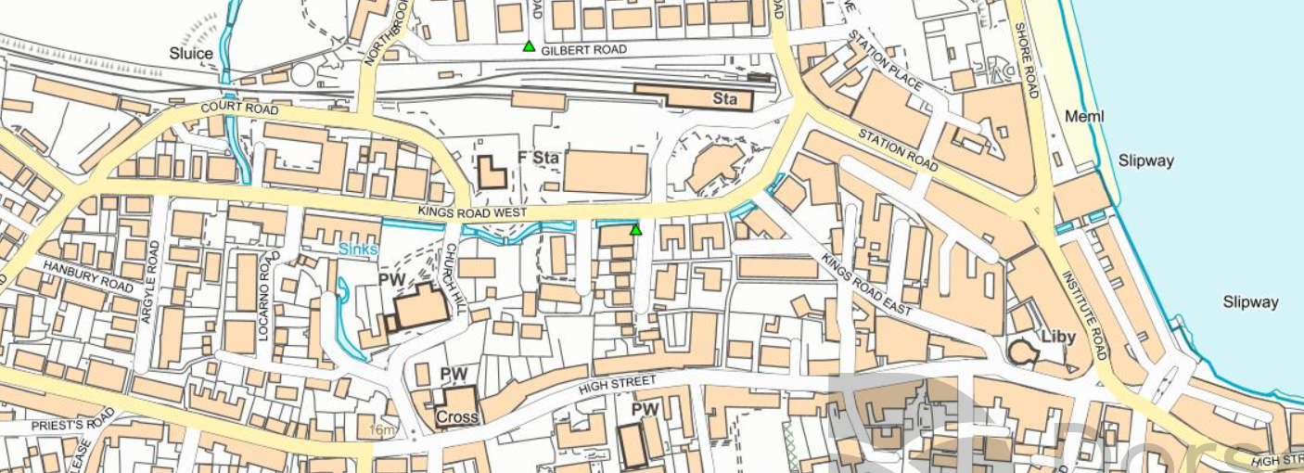
N
Swanage
P4
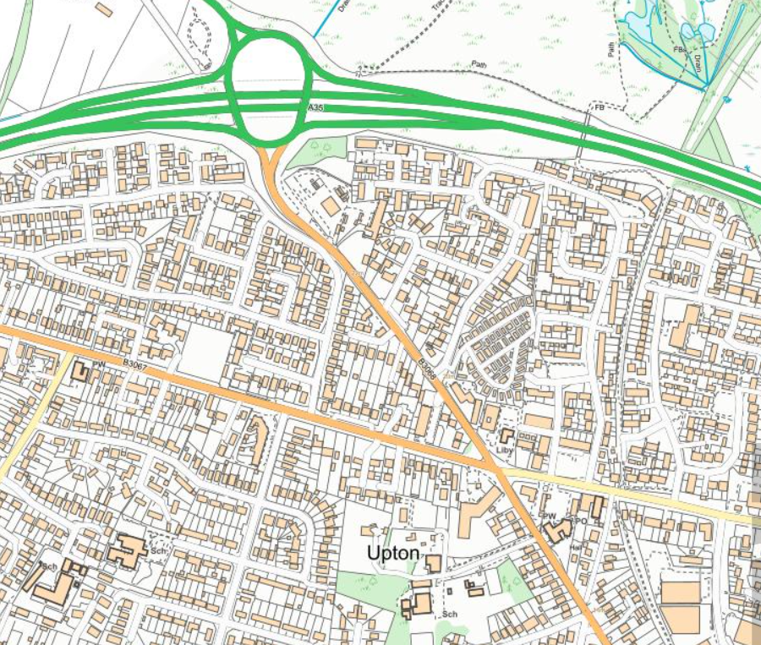
N
P5
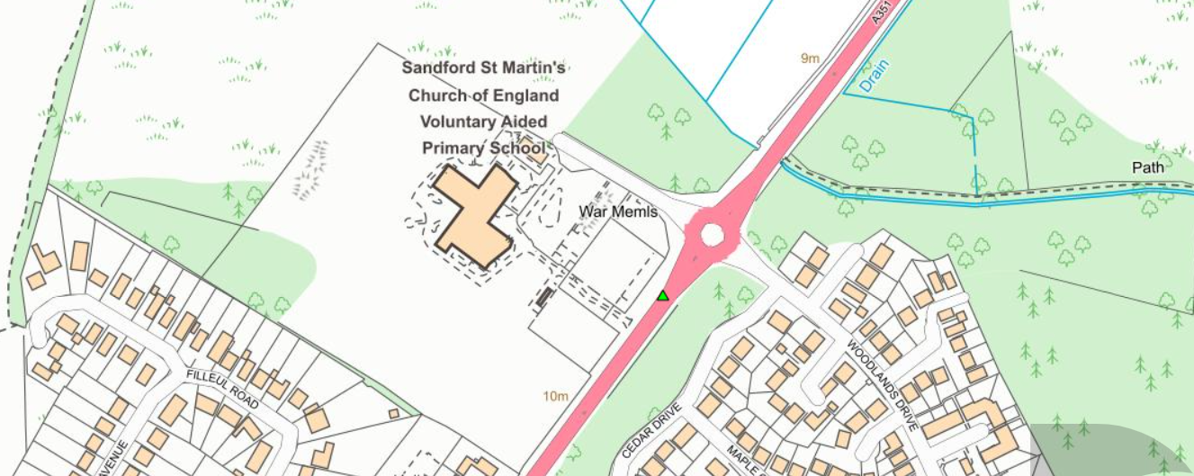
N
P9

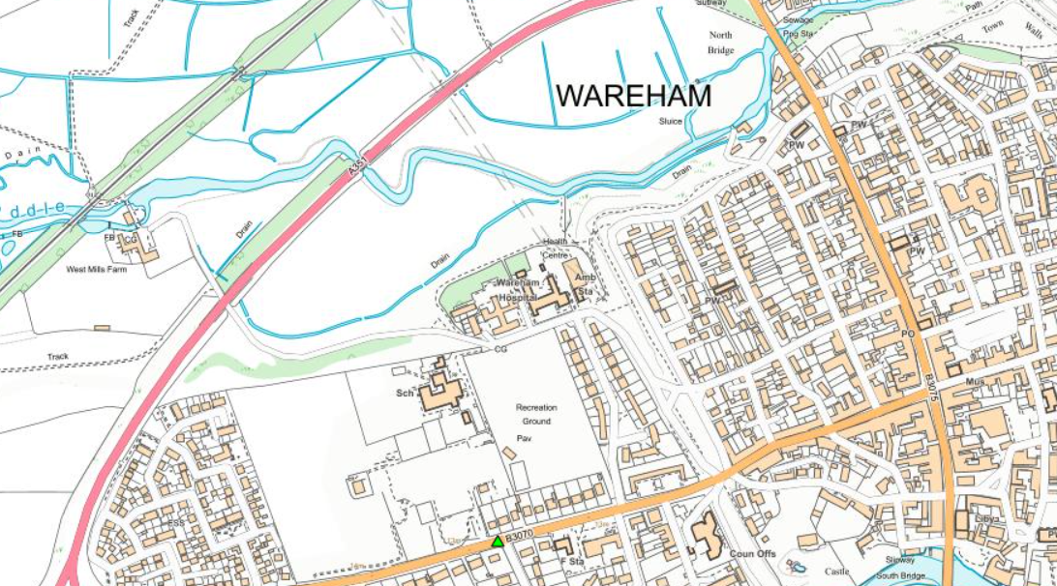
N
P10

Former East Dorset District Council area monitoring locations
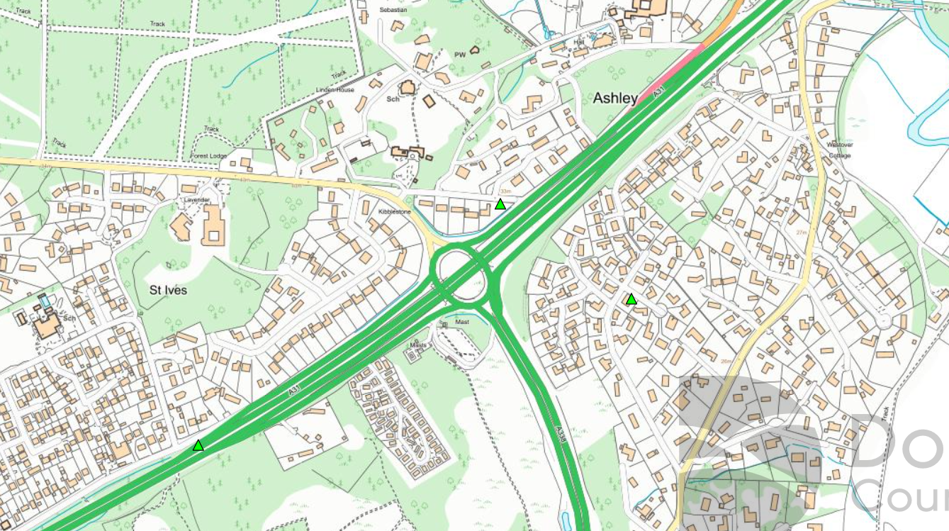
N
E9
E4
E1

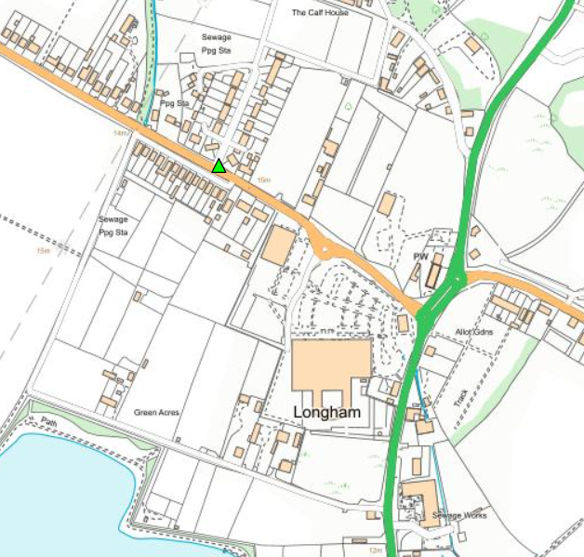
N
E2

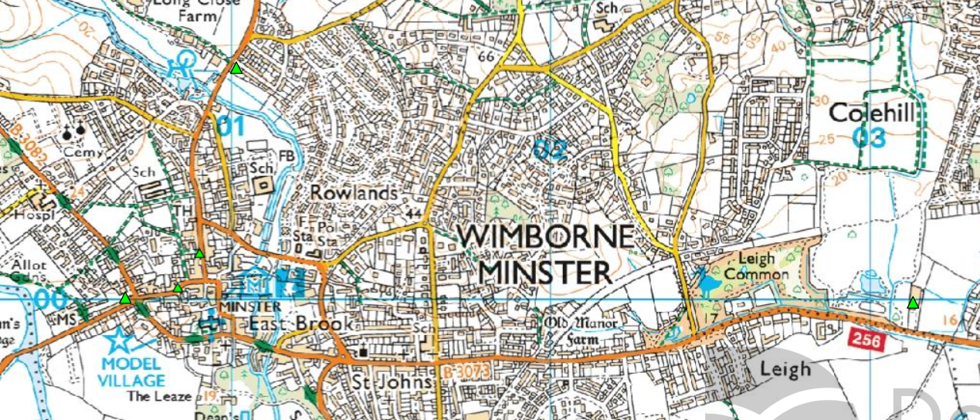
N
E13
E8
E12
E5
E3
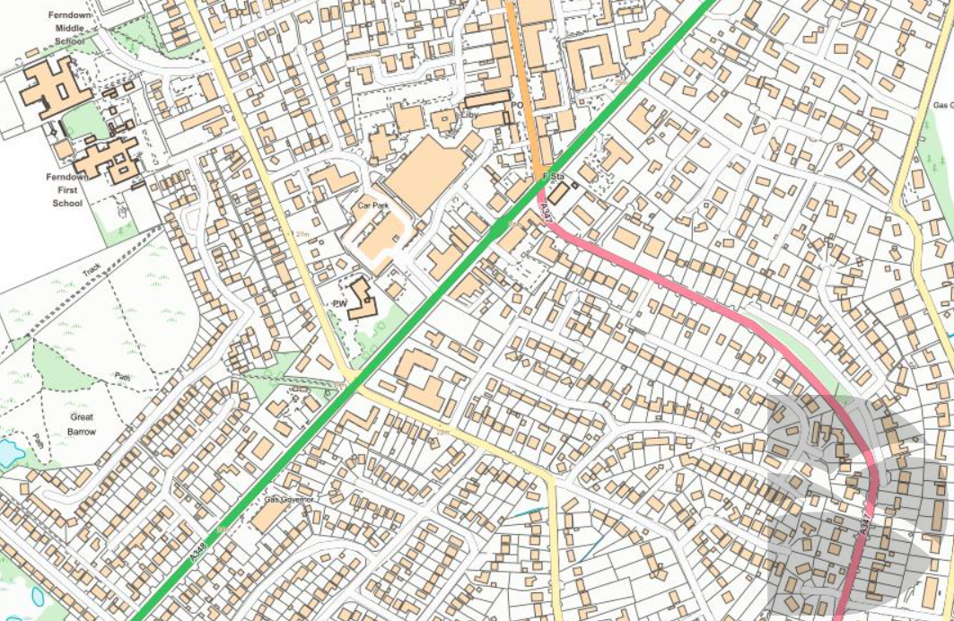
N
E6
Ferndown
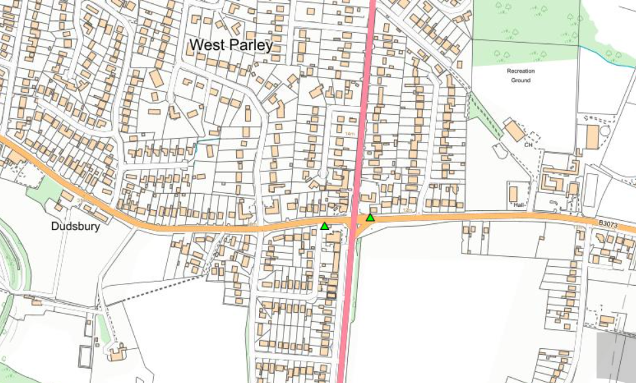
N
E10
E11
Former Weymouth and Portland Borough Council area monitoring locations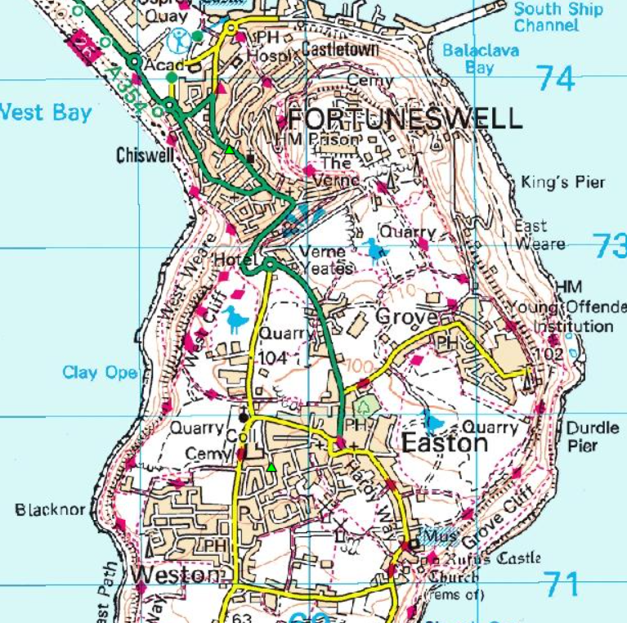
N
W1
W14
W47

W46
W12
W13
W2
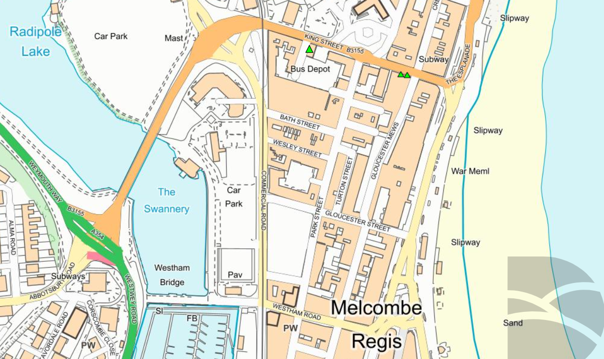
N
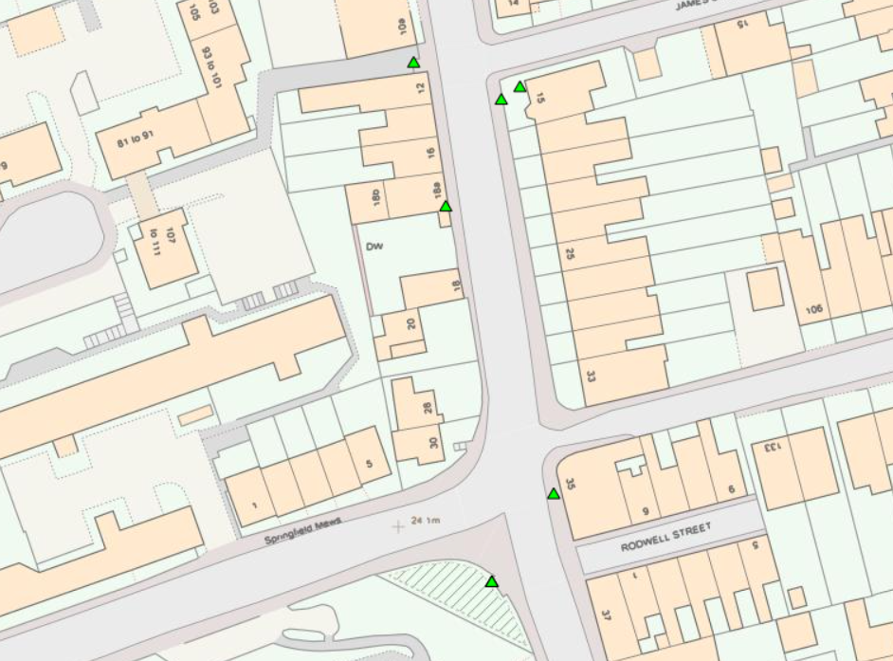
N
W5
Weymouth
W6
W9
W3
W10
Former West Dorset District Council area monitoring locations
W25
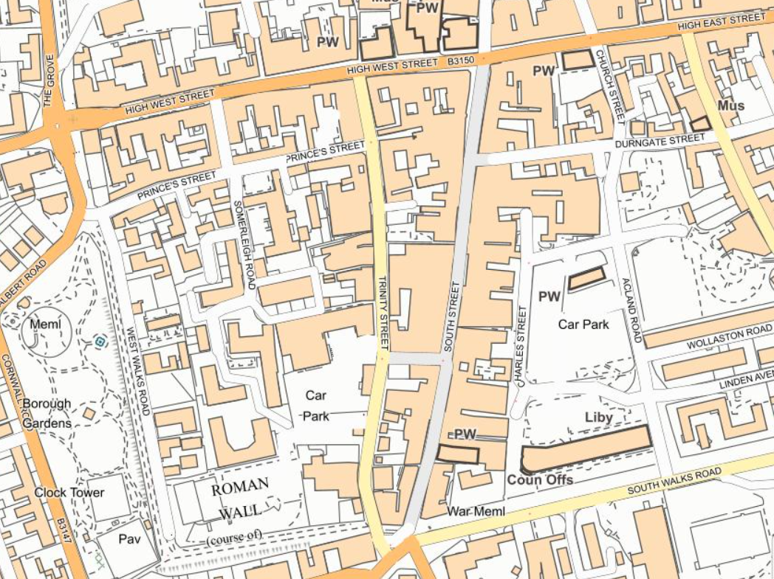
N
W17
W18
W24
Dorchester

W28
W27

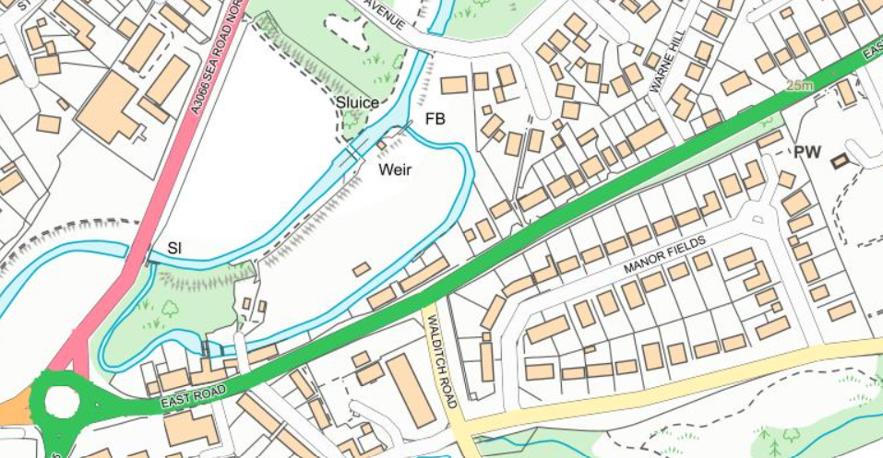
N
Bridport
W29

W37
W32
W33
W38
W39
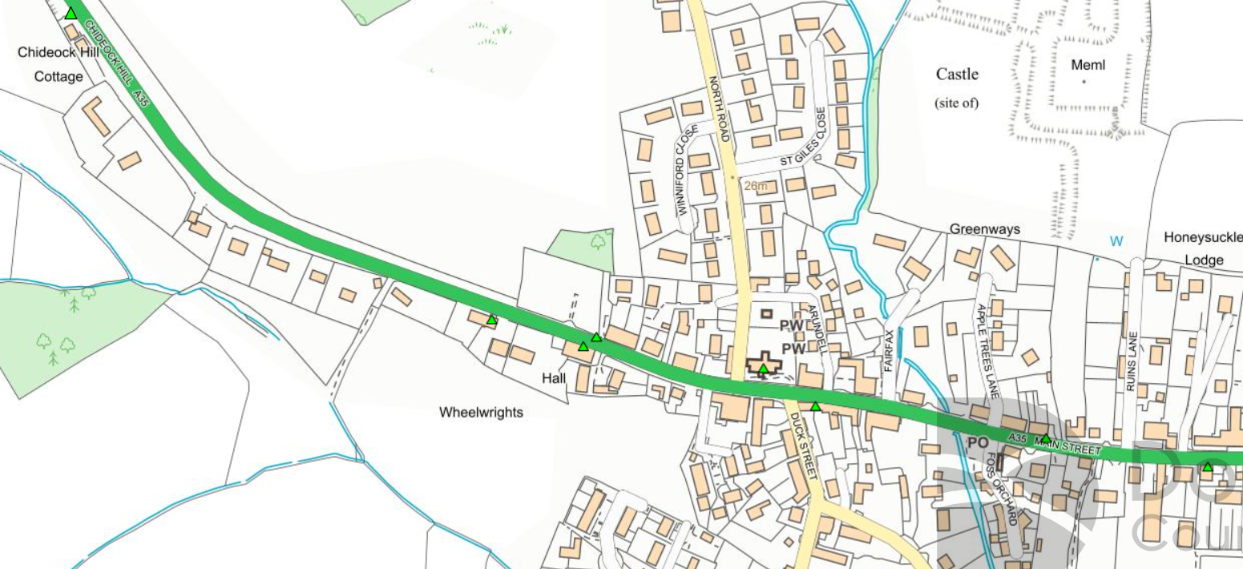
N
W36
W34
Chideock
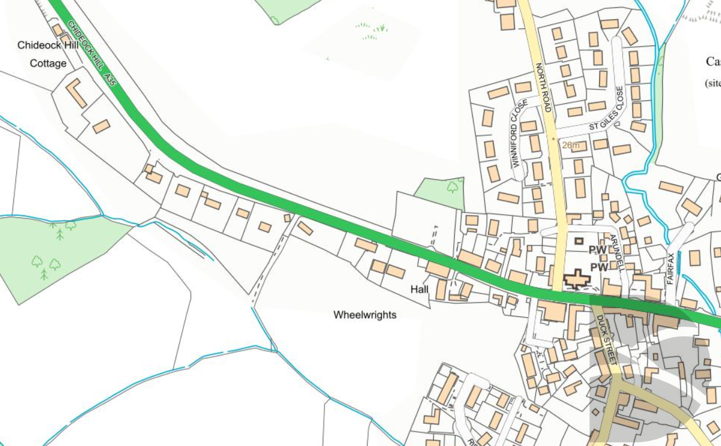
N
Chideock
H8
H1
H7
H6
H5
H2
H3
H4
Former North Dorset District Council area monitoring locations

W40

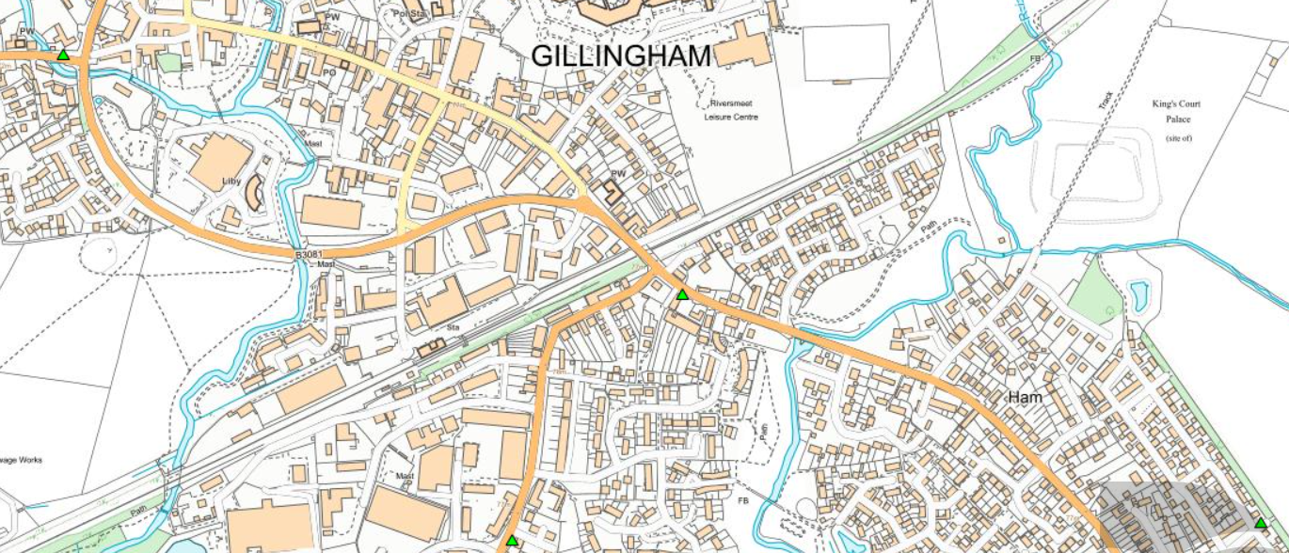
N
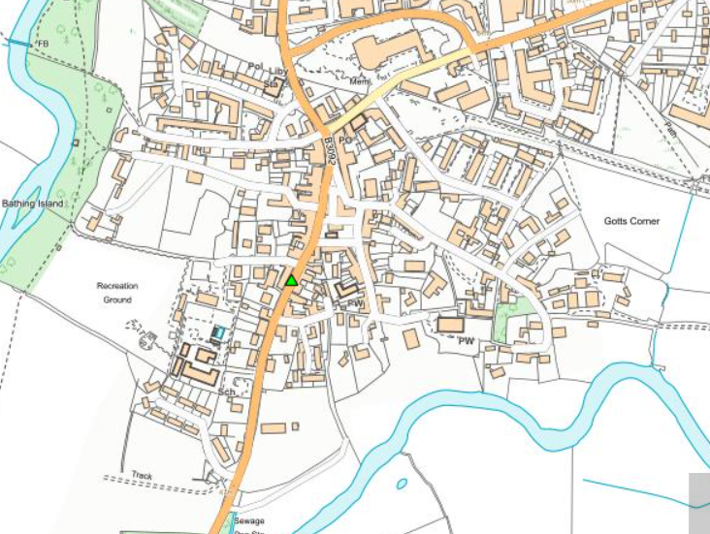
N
Sturminster Newton
W42

AQMesh continuous analyser positons
Beaminster
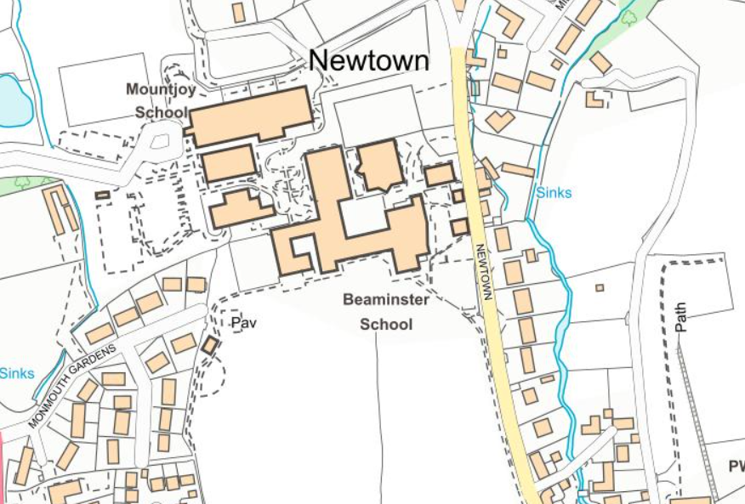
N
Blandford
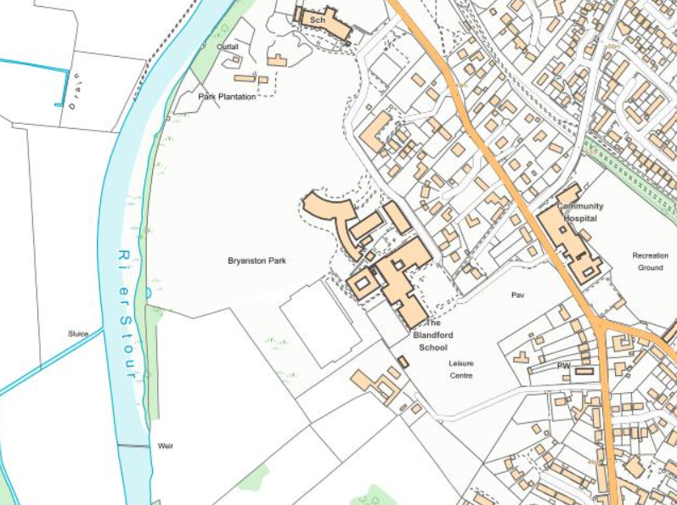
N
Ferndown
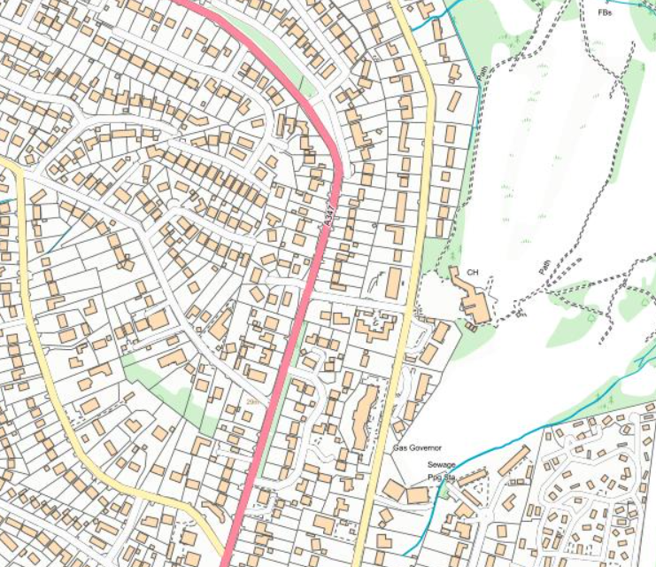
N
Sandford
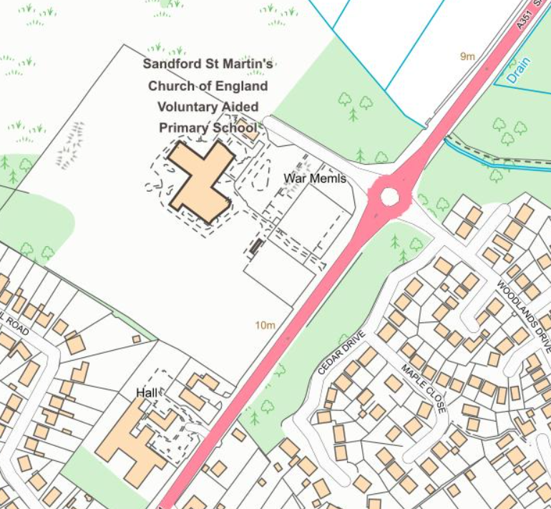
N
Figure D.2 – Map of AQMAs
AQMA Chideock 2007 Boundary
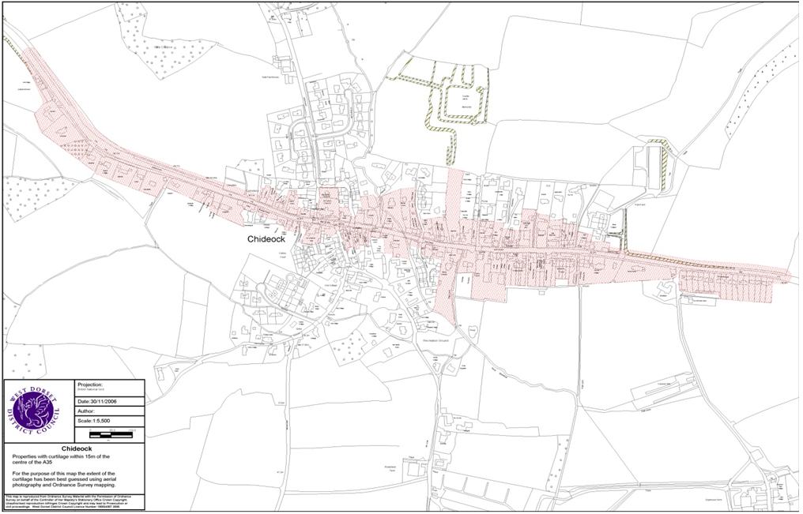
N

AQMA Chideock 2012 Amended Boundary
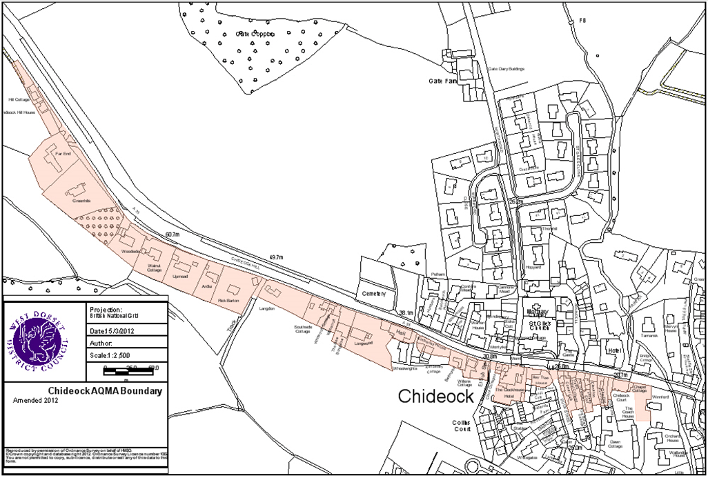
N
AQMA Dorchester 2009
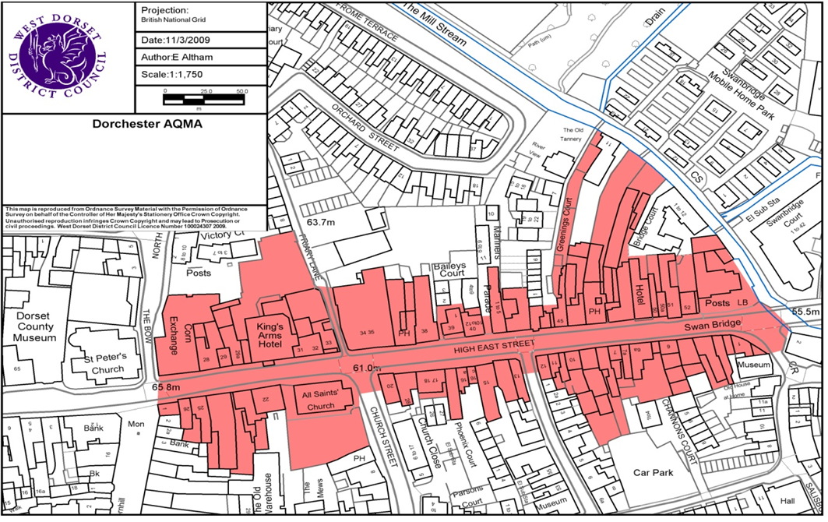
N

Appendix E: Summary of Air Quality Objectives in England
Table E.1 – Air Quality Objectives in England
Pollutant | Air Quality Objective: Concentration | Air Quality Objective: Measured as
Nitrogen Dioxide (NO₂) | 200µg/m³ not to be exceeded more than 18 times a year | 1-hour mean
Nitrogen Dioxide (NO₂) | 40µg/m³ | Annual mean
Particulate Matter (PM₁₀) | 50µg/m³, not to be exceeded more than 35 times a year | 24-hour mean
Particulate Matter (PM₁₀) | 40µg/m³ | Annual mean
Sulphur Dioxide (SO₂) | 350µg/m³, not to be exceeded more than 24 times a year | 1-hour mean
Sulphur Dioxide (SO₂) | 125µg/m³, not to be exceeded more than 3 times a year | 24-hour mean
Sulphur Dioxide (SO₂) | 266µg/m³, not to be exceeded more than 35 times a year | 15-minute mean

Glossary of Terms
Abbreviation | Description
AQAP | Air Quality Action Plan - A detailed description of measures, outcomes, achievement dates and implementation methods, showing how the local authority intends to achieve air quality limit values’
AQMA | Air Quality Management Area – An area where air pollutant concentrations exceed / are likely to exceed the relevant air quality objectives. AQMAs are declared for specific pollutants and objectives
ASR | Annual Status Report
Defra | Department for Environment, Food and Rural Affairs
DMRB | Design Manual for Roads and Bridges – Air quality screening tool produced by National Highways
EU | European Union
FDMS | Filter Dynamics Measurement System
LAQM | Local Air Quality Management
NO₂ | Nitrogen Dioxide
NO_{x} | Nitrogen Oxides
PM₁₀ | Airborne particulate matter with an aerodynamic diameter of 10µm or less
PM_{2.5} | Airborne particulate matter with an aerodynamic diameter of 2.5µm or less
QA/QC | Quality Assurance and Quality Control
SO₂ | Sulphur Dioxide

References
- Local Air Quality Management Technical Guidance LAQM.TG22. August 2022. Published by Defra in partnership with the Scottish Government, Welsh Assembly Government and Department of the Environment Northern Ireland.
- Local Air Quality Management Policy Guidance LAQM.PG22. August 2022. Published by Defra in partnership with the Scottish Government, Welsh Assembly Government and Department of the Environment Northern Ireland.
- Chemical hazards and poisons report: Issue 28. June 2022. Published by UK Health Security Agency
- Air Quality Strategy – Framework for Local Authority Delivery. August 2023. Published by Defra.

UK Health Security Agency. Chemical Hazards and Poisons Report, Issue 28, 2022.
Defra. Air quality and social deprivation in the UK: an environmental inequalities analysis, 2006
Defra. Environmental Improvement Plan 2023, January 2023
Defra. Air Quality Strategy – Framework for Local Authority Delivery, August 2023
DfT. The Road to Zero: Next steps towards cleaner road transport and delivering our Industrial Strategy, July 2018
Defra. Air Quality Strategy – Framework for Local Authority Delivery, August 2023
The units are in microgrammes of pollutant per cubic metre of air (µg/m³).

